

SOCIO-ECONOMIC PROFILE

2007



 MUNICIPALITY OF MAPUN 

PROVINCE OF TAWI-TAWI

S E P

Socio-Economic Profile

2007


Municipality of Mapun
Province of Tawi-Tawi
Autonomous Region in Muslim Mindanao

July 2007

T A B L E O F C O N T E N T S

- Message of the Mayor
- Municipal Map of Mapun
- Location Map of Mapun
- Geographical Map of Mapun

- CHAPTER I. GENERAL INFORMATION 9
General History 9
Geographical Location 9
Topography 10
Climate 10
Ethnic Groups and Language/Dialects 11
Religious Affiliations 11
Land Area 11

- CHAPTER II. HUMAN RESOURCES 12
Population Size 12
Population Growth Rate 12
Population Density 13
Population by Age-Sex Structure 13
Population by Barangay 14
Urban-Rural Distribution 16

- CHAPTER III. ENVIRONMENT & NATURAL RESOURCES 17
Land Area
- Agriculture 17
- Potential Agriculture Land 17
- Grazing and Pasture Land 18
- Swamps, Lakes, & Marshes 18
- Miscellaneous Areas 18
Forestry 18
Mineral Resources 18
Environmental Protection and Management 19
Solid Waste Management 19

- CHAPTER IV. ECONOMIC SECTOR 20
Income and Expenditure 20
Commodity Prices 20
Labor, Employment and Wages 20
Trade 20
Poverty Incidence 21
Agriculture 21
- Key Agricultural Products 22
- Post Harvest Facilities 23
- Irrigation System 23
- Livestock and Poultry 24
Fishery and Aquatic Resources 24
- Fishing Grounds and Fish Production 24
Commerce and Industry 25
Tourism 25
- Tourist Attractions 25
- Accommodations 26
- Accessibility 26
- Traditional Cultural Activities 26
- LGU Income from Tourism 26
Economic Services 27

- CHAPTER V. SOCIAL SERVICES 28
Health
- Crude Birth Rate 28
- Crude Death Rate 28
- Maternal Mortality Rate 29
- Infant Mortality Rate 29
- Total Fertility Rate 29
- Mortality by Leading Causes and by Sex 32
- Proportion of Children 0-5 Years Old Who Died 33
- Morbidity by Leading Causes and by Sex 33
- Proportion of Children 0-5 Years Old
Who are Malnourished 34
- Percentage of Infants with Low Birth Weight 34
- Percentage of Households with Access to
Safe Water, Sanitary Toilets, Basic Sanitation
Facilities & with Satisfactory Garbage Disposal 35
- Number of Health Personnel in LGU 36
- Doctor, Nurse, Hospital Bed, Health Center
To Population Ratio 36
- Percentage of Births Attended by Health Personnel 37
- Contraceptive Prevalence Rate 37
Education
- Literacy Rate 38
- Enrollment by Age and Sex 38
- Drop Out Rate 39
- Number of Teachers per School & by Sex 39
- Pupil to Teacher Ratio 41
- Location and Number of Schools 41
- Vocational/Technical Education 41
- NFE and ECD 41
- School Facilities 42
- Pupil to Classroom Ratio 42
- School Age Population by Age and
Educational Attainment 43
- Number of Day Care Center and Day Care Workers 43
Sports and Recreation 44
Housing and Community Development 44
Land Use 45
Public Safety and Welfare 46
- Protective Services 46

- CHAPTER VI. INFRASTRUCTURE AND UTILITIES 47
Transportation 47
- Land Transportation, Roads and Bridges 47
- Parking Areas 47
- Transportation Facilities 47
- Air Transportation 48
- Sea Transportation 48
- Ports/Wharves 49
Water Resources 49
- Water Sources and Treatment 49
- Flood Control and Drainage 50
Communications 50
Energy and Electrification 50

- CHAPTER VII. ADMINISTRATIVE MACHINERY &
RELATED INSTITUTIONS 51
Administrative Organization and Management 51
- Elected Officials 51
- Appointive Officials 52
- Civil Society Organizations (CSO) 52
- Fiscal Administration 53
Local Income 53
LGU Expenditure 53
20% Development Fund 53

VIII. ANNEXES 54

L O C A T I O N M A P
M U N I C I P A L I T Y O F M A P U N

S a t e l l i t e I m a g e
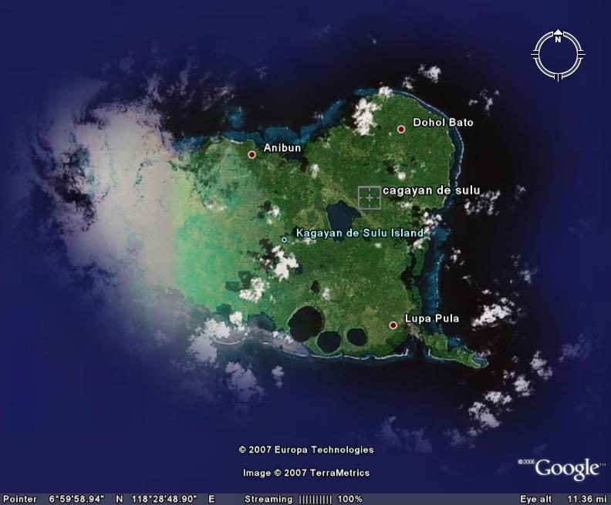
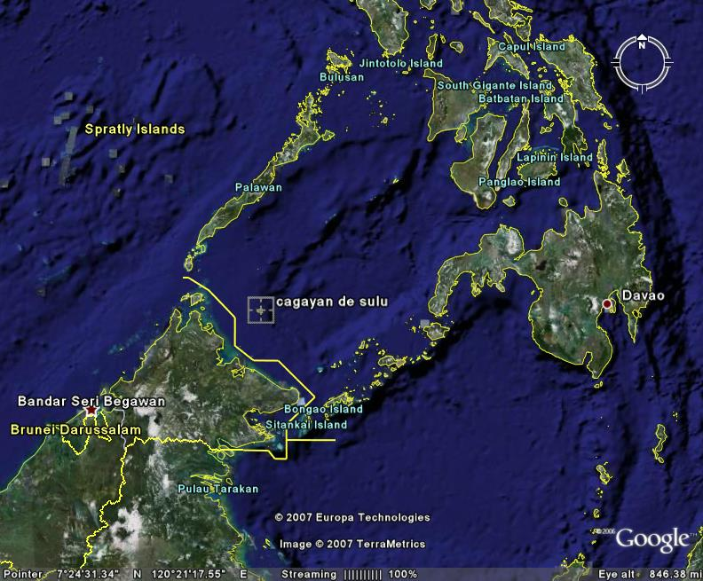
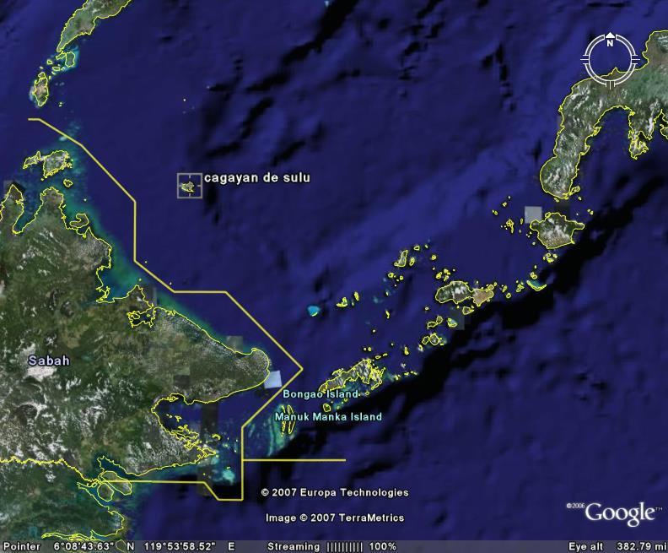

G E O G R A P H I C A L M A P
M U N I C I P A L I T Y O F M A P U N

S a t e l l i t e I m a g e
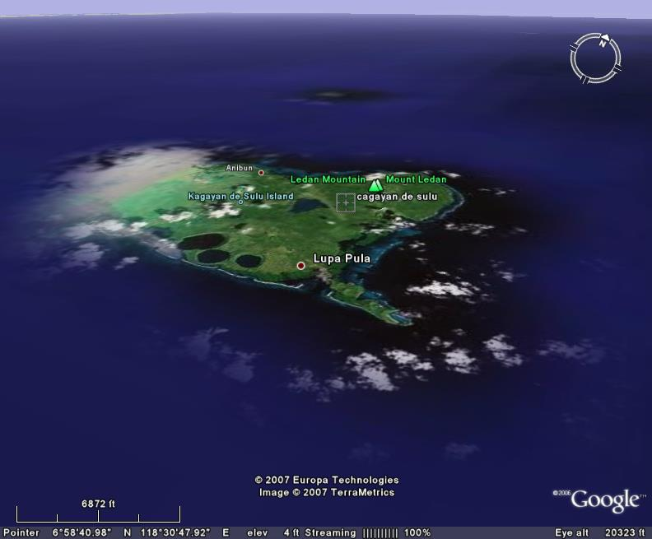
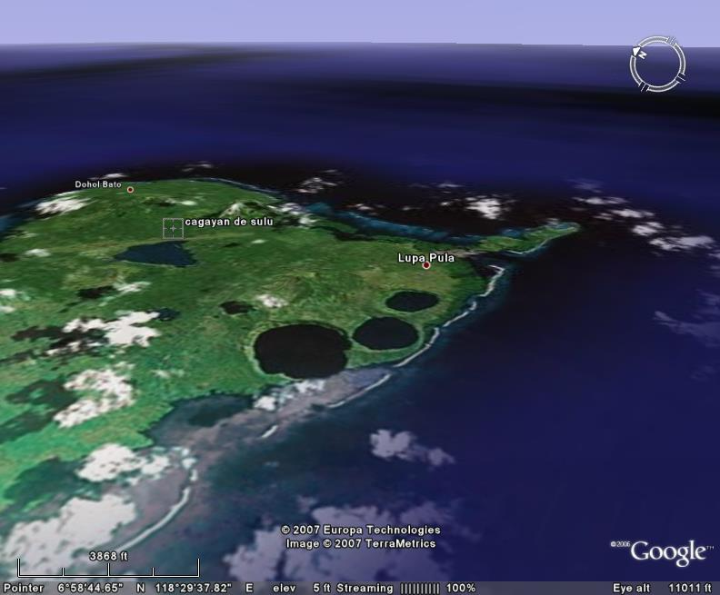

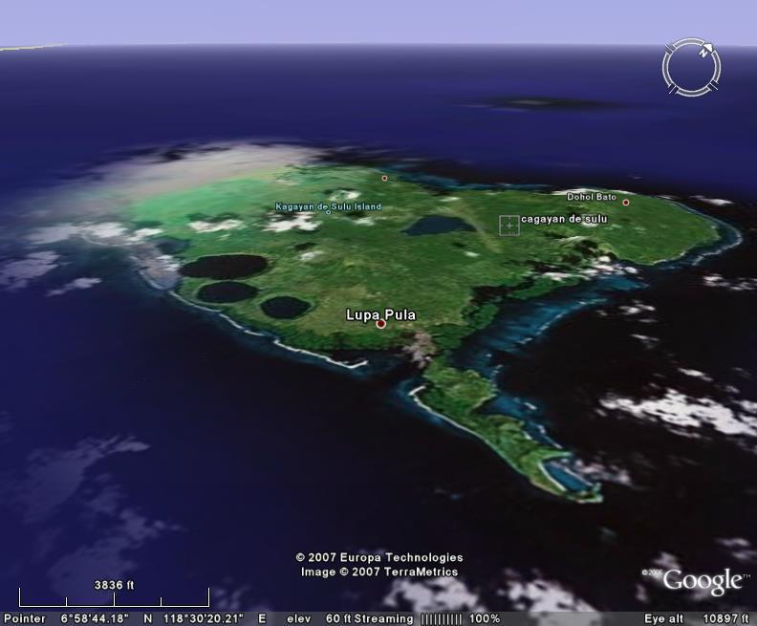
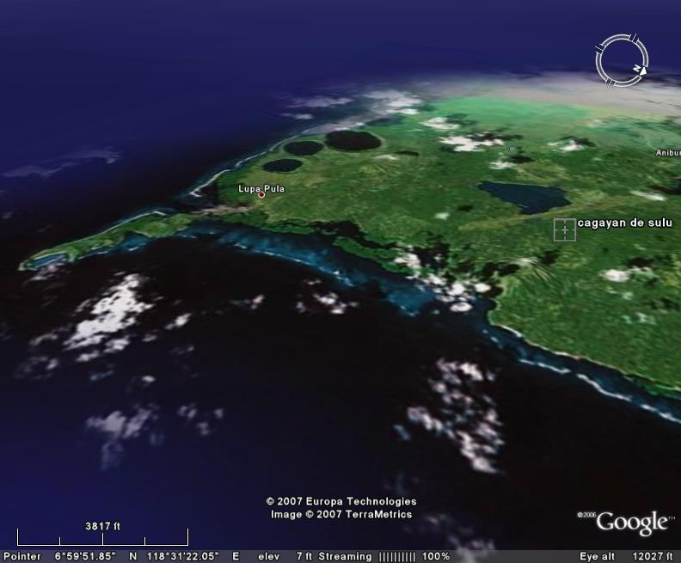

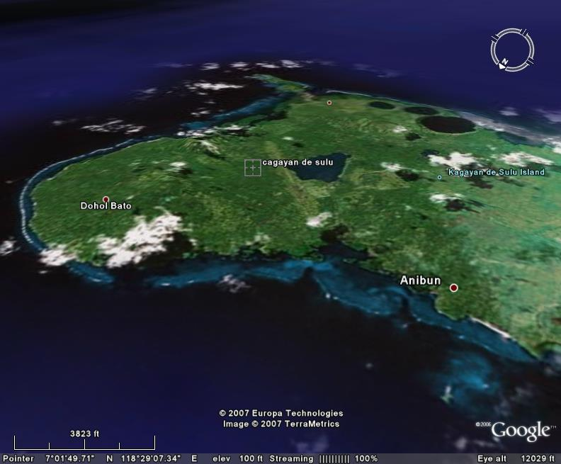
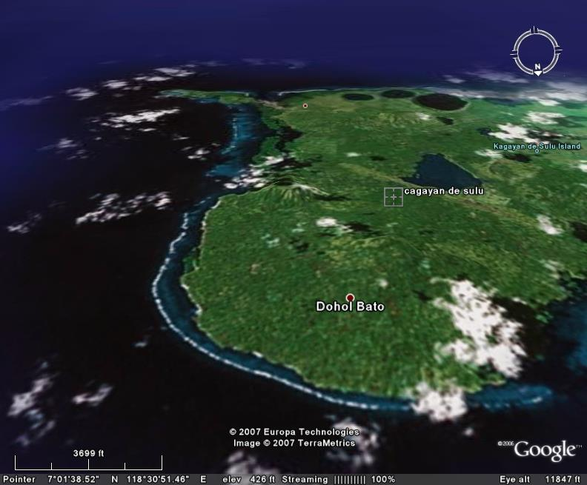

C H A P T E R I
G E N E R A L I N F O R M A T I O N

G e n e r a l H i s t o r y

The word “Mapun” is derived from a Malay term “maaf”, which means forgiveness. In the local dialect, ma-pun means "you forgive" that aptly describes the good values that the peace-loving people in this land possess. This is also the main reason why no matter how many names other people call their home place; the natives always refer to this island as TANAH MAPUN, meaning Land of Mapun.

One of the farthest municipalities from Bongao, the center of the Province of Tawi-Tawi, Mapun was originally called Cagayan de Sulu, being part of Sulu Province then. However, its name was changed to Cagayan de Tawi-Tawi when Tawi-Tawi was created as a separate province out of its mother Province of Sulu by virtue of Presidential Decree Number 302 in 1973. The name Cagayan de Tawi-Tawi also signifies that the place is now part and one of the original municipalities comprising the newly created Province of Tawi-Tawi.

On September 5, 1988, Republic Act Number 6672 signed by then President Corazon C. Aquino has officially given the island its old name, thus the MUNICIPALITY OF MAPUN was born.

During the first election after the EDSA Revolution, Abdulpatta Jumlang, who was then a high school teacher, was elected as the Municipal Mayor of Mapun. He remained as such until his re-election in 1995. Unfortunately, few months later, he was unseated due to election protest and by rule of succession giving the elected Vice Mayor Abdurasid Muksin opportunity to head the local government of Mapun. Unfortunately, Mayor Muksin passed away during his term so Vice Mayor Tahar Danyarrada took over and finished the remaining months of the term. In 1998, Mayor Jumlang ran again and won. He lost when he was vying for reelection in 2001 that paved the way to Mayor Nickerson L. Tan. At present, Mayor Tan is serving as the Local Chief Executive of Mapun in his third term.

G e o g r a p h i c a l L o c a t i o n

The island municipality of Mapun is situated at the western part of the Mindanao Peninsula. To its northwest is the Palawan Peninsula, and to the south is the federal state of Sabah, Malaysia. Its coordinates are Latitude 6.9767 Lat (DMS) 6° 58' 36N and Longitude 118.5136 Long (DMS) 118° 30' 49E.

Mapun is approximately 163 miles northwest of Bongao, the provincial capital of Tawi-Tawi. It is 220 miles west to Zamboanga City and only 69 miles north of Sandakan town of Sabah, Malaysia.

The island municipality can be reached by air or sea transportation from existing travel points Zamboanga City, Bongao, and Brookes Point Palawan. While there is no regular commercial flight to the island, air transportation is possible through once-a-month official trips of the Philippine Air Force from Zamboanga City. Sea transportation is provided by seven sea vessels regularly traveling the Mapun-Zamboanga City and vice-versa route. Sea travel time from Zamboanga City usually takes more than 27 hours while from Bongao, Mapun is reached within 20 hours. Mapun-Palawan via Brookes Point sea route takes 14-15 hours using motor launches. Privately-owned small motorboats in Mapun could travel from the island municipality to Sandakan, Sabah Malaysia in 8 hours while fast sea crafts like speedboats could ferry passengers to the place only in 2 hours time.

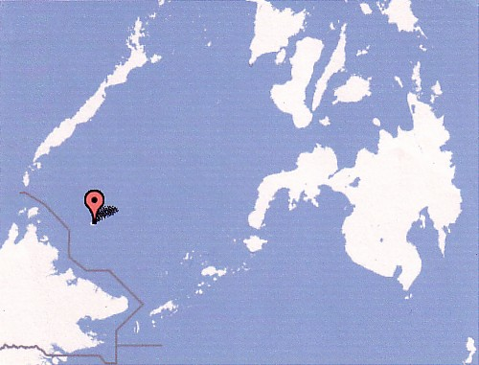
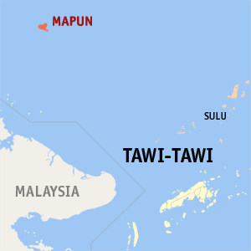
Latitude 6.9767 Lat (DMS) 6° 58' 36N
Longitude 118.5136 Long (DMS) 118° 30' 49E
Mapun
Zamboanga
Palawan
Sabah
Bongao

T o p o g r a p h y

The main island of Mapun and its surrounding 17 islets are of volcanic origin and all may be classified as high island types.

There are 26 mountains on the island, the highest peak Mt. Liran (1,105 ft. above sea level) is sprawled over the barangays of Guppah, Duhul Batu and Sapah. The interior of the island is a vista of low green hills and cones rising from sloping valleys and miniature plains.

The most remarkable feature of Mapun is the two freshwater crater lakes (Danao and Singuwang) and a crater bay whose seaward walls opens to the sea to form Jurata Bay. Found some 40 feet above sea level, the two lakes are nearly perfect circles, separated only by a few meters of solid rock. Another lake called Sapah Lake is found near the center of the island. It is marsh-like and formed by the accumulation of rainwater over time and is approximately 69 hectares in area.

C l i m a t e

The island municipality is classified under the 4th type of climate having distinct dry and wet seasons and is characterized by evenly distributed rainfall throughout the year. Heavy rains occur during the months of August to November. March and April are the hot summer months when most water sources in the highlands of the interior dry up. The island however has a normal average rainfall.

All types of winds reach the island from different directions at different times of the year. The most notable types due to their regularity are the following:

Southerly wind (Sa-atan) : June – October
Westerly wind (Balat) : June – October
Northerly wind (Uttarah) : December – April
Northeasterly wind (Timulaut): December – April

Travel advisory suggests the month of May as the best month to travel to and from the island when the winds and the sea are calm.

E t h n i c G r o u p s a n d L a n g u a g e / D i a l e c t s

The largest ethnic group is the Jama Mapun or the original inhabitants of the island where the local dialect Pullun Mapun remains as the predominant dialect being used. Other ethnic groups comprise the Sama Badjao, Pangutaran (Sulu), Tausug (Sulu), Yakan (Basilan) and a few others from Luzon and Visayas. It is of note however that in the Poblacion comprising the barangays of Liyubud and Lupah Pula, Bahasa Tausug is the dialect widely spoken. Siyama (Badjao dialect), Pangutaran, Cebuano, Chavacano, Illongo, Bahasa Malaysia or Malayu, English and Tagalog are also spoken on the island.

R e l i g i o u s A f f i l i a t i o n s

Over 90% of the population professes the Islamic faith. The rest are Roman Catholics, Protestants, Seventh Day Adventists, Jehovah’s Witnesses and other faiths.

L a n d A r e a

Mapun has a total land area of 28,129 hectares or 281.29 sq. km. that is divided into fifteen (15) barangays. According to the 2002 DAF (Department of Agricultural and Fisheries) Report, the use of land in general in the island municipality is as follows:

Table 1.1 Mapun Land Area and Land Use Category
Land Use Category | Land Area
Land Use Category | Hectares (ha) | Percentage (%)
Agriculture | 6,270 | 50.89
Potential Agricultural Land | 5,540 | 44.97
Forestland | 4 | .03
Lakes, Swamps, and Marshes | 121 | .98
Grazing and Pasture Lands | 285 | 2.31
Inland Fishery Area | 10 | .08
Settlements Area | 90 | .73
Fishing Ground* | Mapun Sea | ***
Total | 12,320 | 99.99
*Area of Fishing Ground not included in number data
C H A P T E R I I

H U M A N R E S O U R C E S

P o p u l a t i o n S i z e

Table 1.2 Population of Mapun Municipality, Integrated Provincial Health Office (IPHO), Tawi-Tawi
Year | Population | Population Growth
2000 | 22,011 (NSO) | Base Year
2001 | 22,429 | 418
2002 | 22,855 | 426
2003 | 23,290 | 435
2004 | 23,732 | 442
2005 | 24,183 | 451
2006 | 24,643 | 460
2007 | 25,111 | 468
2008 | 25,588 | 477

The estimated population size of Mapun municipality in 2007 projected by the Integrated Provincial Health Office (IPHO) Tawi-Tawi is 25,111. Population has grown by 3,100 since year 2000, the base year wherein the population of the municipality is officially recorded by the National Statistics Office (NSO) at 22,011. This census figure conducted by the NSO however has been disputed by local officials because it failed to consider the seasonal migration pattern of the labor sector in the area. A sizeable number of highlanders briefly migrate to Sabah, Malaysia for seasonal job opportunities where they return to the island immediately after within the year of their departure.



Ý
P o p u l a t i o n G r o w t h R a t e

Based on the official 5-year span census of population and housing recorded by the National Statistics Office (NSO), the average annual population growth rate of Mapun Municipality in 1990 was 0.12%. After 5 years in 1995, its average annual population growth rate grew to 1.38%. In 2000, the municipality registered an annual population growth rate of 1.25%.

Table 1.3 Mapun Total Population and Growth Rate

Year | Population | Average Annual  Population Growth
1990 | 19,372 | 0.12%
1995 | 20,716 | 1.38%
2000 | 22,011 | 1.25%

P o p u l a t i o n D e n s i t y

Based on its 22,011 population and land area of 281.29 square kilometers (28,129 hectares), the population density of Mapun is 78 persons per sq.km. or population density of 0.78.

P o p u l a t i o n b y A g e – S e x S t r u c t u r e



- Population Composition by 5-Year Age Group and by Sex

Graph 1.1: Population Pyramid, Municipality of Mapun, NSO 2000.

The Population Pyramid of Mapun Municipality based on the 2000 census on population and housing conducted by the National Statistics Office (NSO) shows a triangle-shaped pyramid and reflects an expanding population. For both sexes male and female, the population in its 5-year age grouping is greater from the base up. Population growth rate in 2000 is about 1.25 percent annually.

The total male population is 10,847 while the total female population is 11,164. Females outnumber males by 317 in real number. In percentage, 49% of the total population in the municipality are males while 51% are females. Male-female ratio is almost 1:1.

The 5-9 and 10-14 age groups have the highest number of population in both sexes. In total population however, 49% belongs to 0-17 age group and 51% belongs to 18 and over in both sexes. Table 1.4 illustrates more clearly the distribution of population in 5-year age groups and by sex.

Table 1.4 Total Population by Sex and Age Group, Municipality of Mapun, Tawi-Tawi, NSO 2000

Age Group | Female | Male | Both Sexes
All Ages | 11,164 | 10,847 | 22,011
Under 1 | 248 | 286 | 534
1-4 | 1,272 | 1,274 | 2,546
5-9 | 1,638 | 1,569 | 3,207
10-14 | 1,471 | 1,396 | 2,867
15-19 | 1,313 | 1,208 | 2,521
20-24 | 999 | 997 | 1,996
25-29 | 863 | 831 | 1,694
30-34 | 582 | 583 | 1,165
35-39 | 672 | 594 | 1,266
40-44 | 473 | 464 | 937
45-49 | 466 | 473 | 939
50-54 | 323 | 335 | 658
55-59 | 279 | 239 | 518
60-64 | 175 | 221 | 396
65-69 | 142 | 137 | 279
70-74 | 116 | 114 | 230
75-79 | 74 | 63 | 137
80 and over | 58 | 63 | 121
0-17 | 5,415 | 5,264 | 10,679
18 and over | 5,749 | 5,583 | 11,332

P o p u l a t i o n b y B a r a n g a y

The capital town of Mapun, Barangay Liyubud, where the seat of the municipal government is located, registers the highest population and household population at 2,680. Barangay Mahalu ranks second with 2,162, followed by Barangay Umus Mataha with 2,153. (see Table 1.5)

Barangay Kumpang has the lowest population with only 618. This is only 23% of the population of Mapun’s capital town. Lubbak Parang ranks second lowest with 776, followed by Barangay Iruk-Iruk with 804.

As to number of households, Liyubud has the highest number with 411 households, followed by Umus Mataha with 367, and Boki with 332. Kumpang has the smallest number of households with104. (see Table 1.5)

Table 1.5 Total Population, Household Population, Number of Households by Barangay, Municipality of Mapun, Tawi-Tawi, NSO 2000

Barangay | Total Population | Household Population | Number of Households
Boki | 2,096 | 2,096 | 332
Duhul Batu | 1,322 | 1,322 | 225
Kumpang | 618 | 618 | 104
Pawan | 1,228 | 1,228 | 179
Sikub | 1,236 | 1,236 | 195
Tabulian | 1,045 | 1,045 | 178
Iruk-Iruk | 804 | 804 | 116
Guppah | 1,961 | 1,961 | 322
Liyubud | 2,680 | 2,680 | 411
Upper Lupah Pula | 1,163 | 1,155 | 167
Lubbak Parang | 776 | 776 | 132
Mahalu | 2,162 | 2,162 | 322
Sapah | 1,720 | 1,716 | 282
Tanduan | 1,047 | 1,047 | 160
Umus Mataha | 2,153 | 2,153 | 367
TOTAL | 22,011 | 21,999 | 3,492

The graph below illustrates the population distribution per barangay in Mapun in census year 2000. Capital town Barangay Liyubud has the highest population while Barangay Kumpang is the smallest town with only 23% of Liyubud’s population size:

Graph 1.2 Total Population by Barangay, Municipality of Mapun, Tawi-Tawi, NSO 2000

U r b a n – R u r a l D i s t r i b u t i o n

Mapun is predominantly a rural community. Of the 15 barangays in the island, adjoining barangays Liyubud (Lower Lupah Pula) and Lupah Pula (Upper Lupah Pula) are the only two barangays classified as urban areas while the remaining 13 are rural barangays. Most of the population or 82.6% are living in the rural areas or in their farms while only 17.4% or 3,843 people are living in the urban areas. In terms of households, 2,914 or 83.4% are located in the rural areas. Only 578 are situated in the center of the municipality.

Table 1.6 Total Population and Number of Households Distributed in Urban and Rural Areas, Municipality of Mapun, Tawi-Tawi, NSO 2000

Classification | Total Population | Number of Households
URBAN | 3,843 | 578
RURAL | 18,168 | 2,914
TOTAL | 22,011 | 3,492

The graph below illustrates urban-rural distribution in census year 2000. Mapun being a predominantly rural community can be clearly seen in this presentation:

Graph 1.3 Population by Urban and Rural Distribution , Municipality of Mapun, Tawi-Tawi, NSO 2000

C H A P T E R I I I
E N V I R O N M E N T A N D N A T U R A L R E S O U R C E S

L a n d A r e a

Mapun has a total land area of 28,129 hectares or 281.29 sq. km. that is divided into fifteen (15) barangays. According to the 2002 DAF (Department of Agricultural and Fisheries) Report, the use of land in general in the island municipality is as follows:

Table 1.1 Mapun Land Area and Land Use Category
Land Use  Category | Land Area
Land Use  Category | Hectares (ha) | Percentage (%)
Agriculture | 6,270 | 50.89
Potential Agricultural Land | 5,540 | 44.97
Forestland | 4 | .03
Lakes, Swamps, and Marshes | 121 | .98
Grazing and Pasture Lands | 285 | 2.31
Inland Fishery Area | 10 | .08
Settlements Area | 90 | .73
Fishing Ground* | Mapun Sea | ***
Total | 12,320 | 99.99

*Area of Fishing Ground not included in number data

- Agriculture

This is the most extensive land use covering approximately 6,270 hectares or 50.89% of the total land use area. Based on the report of the Department of Agriculture and Fisheries, the top earning agricultural industry in Mapun is Copra Production with an estimated production of 14,000 metric tons. More than 90% of the land area is planted with coconut. There is no data however, on the exact number of hectares of land planted with coconut or the number of farmers served. Coconut is planted and seen everywhere even in the heart of the Poblacion. Other crops grown are banana (next to copra in popularity), cassava, native mangoes, and coffee. Although rice and cassava are staple foods, rice is still imported from Palawan, Zamboanga and even from Sabah, Malaysia.

- Potential Agriculture Land

Around 5,540 hectares or 44.97% of the land use area is not yet developed and has been designated as potential land for agriculture.

- Grazing and Pasture Land

Pasture and grazing lands are the second most extensive land use in the island after agricultural lands covering approximately 285 hectares of the total land use area. Pasture animals include goats and cattle. While cattle are principally used as work animals for the farms, they are slaughtered only on certain occasions such as weddings, death and birth days. Beef is usually bought in Sandakan, Malaysia, which is nearer than Bongao or Zamboanga. It is of note however that livestock is sometimes associated with poultry raising that is more characterized as backyard industries.

- Lakes, Swamps, and Marshes

These include the three great lakes of Mapun, Danao, Singuwang, and Sapah, rivers and creeks, as well as swamps and marshlands. These natural sources of water and water systems remain clean and uncontaminated. Pollution level is low and manageable as high scale commercialization and tourism is not yet present in the island.

- Miscellaneous Areas

These include inland fishery area, which covers approximately 10 hectares, settlements area, which covers approximately 90 hectares and fishing grounds that covers the Mapun Sea.

P
P
F o r e s t r y

- Forest Land

Only 4 hectares or .03% of the land use area has been utilized for forestry purposes. This is due to no logging operations in the island as timber standing is low. Most of the trees are of the gemelina variety while forests in the coastal areas are of the dipterocarp mangrove type, all of which are non-commercial types.

M i n e r a l R e s o u r c e s

There is no known metallic reserve on the island. However, Mapun is rich in sand and gravel.

The possibility of having oil as mineral resource is being currently explored by the consortium led by UNILOCAL SULU LTD, in an area covering about 8,000 sq. km. and in deep waters of the Sulu Sea to the Southeast of Mapun Island.

E n v i r o n m e n t a l P r o t e c t i o n a n d M a n a g e m e n t

Using illegal methods in fishing would be detrimental to marine and coastal environment; hence local ordinances and other legislations that would help protect the environment would be necessary.
Also, waste and garbage thrown in the seawater cause pollution in marine ecology that would destroy the growth of marine plants and animals.
The local government has yet to formulate its ecological waste management plan in order to properly manage the conservation and protection of both land-based and marine environments.
ê
Q
S o l i d W a s t e M a n a g e m e n t

As most residents live at the coastal areas, waste and garbage of all sorts are easily thrown and dumped in the seawater.
As shown in the table below, only few households have sanitary toilets and sanitation facilities. Proper sanitation and garbage disposal need to be disseminated in order for the people to know the disadvantages of having a polluted environment.
Those with land-based houses usually burn their garbage and at times throw their waste also to the sea.
At present the environmental problems in Mapun is still negligible and manageable. The people and the Local government Unit are vigilant and careful not to destroy the environment specially the marine life.
Also, since there are no big industries that could possibly be sources of much waste and garbage, garbage truck collector has not been given priority by the local government. Moreover, it has still to formulate its program on proper waste disposal wherein disposal sites would be designated far from the residential areas.

Table 1.7 Environmental Health Report, DOH, Mapun, Tawi-Tawi, 2003
Nature of Data | 2000 |  | 2001 | 2002 | 2003
1. No. of HH with sanitary toilets | 796 |  | 801 | 837 | 840
2. No. of HH with satisfactory garbage disposal | 2,696 |  | 2,698 | 2,748 | 3,101
3. No. of HH with complete basic sanitation facilities | 383 |  | 385 | 398 | 405
4. No. of Food establishments | 17 | 17 |  | 100 | 103
5. No of Food establishments with sanitary permit | 17 | 17 |  | 100 | 103
6. No. of Food Handlers | 26 | 26 |  | 65 | 70
7. No. of Food Handlers with Health Certificates | 26 | 26 |  | 65 | 70

C H A P T E R I V
E C O N O M I C S E C T O R

I n c o m e a n d E x p e n d i t u r e

1,438 families in the barangays rely on farming as major source of living while 1,756 families make fishing as major sources of income. Using the traditional way of tilling the fields/farms, the farmers have meager income that is very insufficient to support the basic needs of family members. Likewise, fisher folks go fishing along the Mapun waters using hook and line that provide them with small volume of fish catch. Many farmers also while waiting for the harvest season go fishing for family consumption and at times selling the extra fish catch to provide money for other needs.
This meager income derived from fishing and farming is budgeted basically for daily food intake, education for the children, medicines and other health related needs, clothing and social obligations like weddings and death within the family circle or in the community.
P
C o m m o d i t y P r i c e s

The Department of Trade and Industry has no committee or local agents that serve as the Local Price Regulatory Board. This Board should have safeguarded the prices of basic commodities. In the absence of a regulatory board, local dealers of basic commodities and other goods are basing prices according to the amount they spent in buying the goods plus incidental expenses incurred like transportation and damages if there are any and demand of the product.
Agricultural products on the other hand like vegetables and fruits are sold not by kilo but by small bunch at fixed and affordable prices. Likewise, fishery products are sold in the same manner.

L a b o r , E m p l o y m e n t a n d W a g e s

Most people in Mapun Municipality are engaged in agriculture and fishing. According to the report of the Department of Agriculture and Fisheries, the total number of families that are engaged in farming is 1,438 while the total number of families engaged in fishing is 1,756. But on the other hand, there are also 123 families that do not consider farming as their major source of living and 96 families that do not consider fishing as their major source of income.
Labor force is composed of farmers, skilled, fisher folks, and others. At times, children are forced to leave school and assist their farmer-parents during harvest time. There are also those that are working in the government but only few.

T r a d e

People in Mapun trade basic commodities with nearby Malaysia. In-coming trade goods comprise of sugar, rice, coffee, carbon, liquefied petroleum gas or LPG, and food substitutes like instant noodles. These goods however are not sourced mainly in Malaysia but also locally in Zamboanga. These goods provide alternative options for the consumers in the municipality.
Out-going trade goods to Malaysia are mostly assorted fishes and other yields of the sea as most people in the municipality are fisher folks. Harvests from the sea give more trading advantage than harvests from the farm as agricultural produce are mostly staple goods grown for local consumption and not for trading.

P o v e r t y I n c i d e n c e

There is no municipal data yet on poverty incidence and poverty statistics. However, based on the latest national and regional poverty statistics by the National Statistical Coordination Board (NSCB), the ARMM Region still remains as one of the poorest region in the country with 53.1% poverty incidence of population in 2003. This statistic dropped from 59.8% in year 2000.
Among the top 44 poorest provinces listed by the NSCB, all the four provinces of the ARMM region are included with the province of Tawi-Tawi having a poverty incidence of 60.2% of the population in year 2000. This statistic increased by 21 percentage points from 1997 wherein poverty incidence of the population was 39.2%

A g r i c u l t u r e

- Agricultural Land Area and Potential Agri-Areas

In the given data on Current Land Use, Mapun has a total agricultural land area of 6,270 hectares, the most extensive land use and potential agricultural land area of 5,540 hectares.
Table 1.1 Mapun Land Area and Land Use Category
Land Use  Category | Land Area
Land Use  Category | Hectares (ha) | Percentage (%)
Agriculture | 6,270 | 50.89
Potential Agricultural Land | 5,540 | 44.97
Forestland | 4 | .03
Lakes, Swamps, and Marshes | 121 | .98
Grazing and Pasture Lands | 285 | 2.31
Inland Fishery Area | 10 | .08
Settlements Area | 90 | .73
Fishing Ground* | Mapun Sea | ***
Total | 12,320 | 99.99

*Area of Fishing Ground not included in number data

- Key Agricultural Products and Crop Production

Based on the report of the Department of Agriculture and Fisheries, the top earning agricultural industry in Mapun is Copra Production with a local estimated production of 14,000 metric tons. More than 90 % of the total land area is planted with coconut, but there is no data on the exact number of hectares of land planted with coconut or the number of farmers served. However, coconut is planted and seen everywhere, even in the heart of the Poblacion.
Next to copra is banana production. An estimate made in 1992 placed the annual production of bananas (Sabah) at 40,000 bunches or about 300 metric tons.
Other food crops like cassava; native mangoes and coffee are also grown in the island. Only about ten hectares of land have been planted with coffee.
Rice and cassava are staple foods for islanders. Only cassava is most commonly planted, even in the backyard. Rice is still imported from Palawan, Zamboanga and even from Sabah, Malaysia.

Table 1.8 Crop Production, Mapun, Tawi-Tawi, 2001
CROPS | DETAILS | 2001
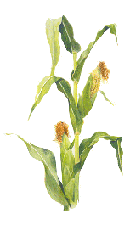  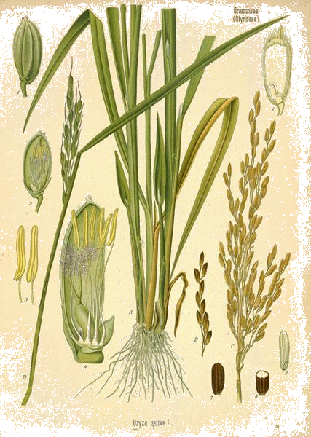  PALAY | Rainfed Lowland/update | 50
 | Area Planted (in has) | 50
 | Area Harvested (in has) | 50
 | Production (in M.T.) | 100
CORN      (YELLOW) | Area Planted (in has) | 30
 | Area Harvested in has | 30
 | Production in M.T. | 36
CASSAVA | Area Planted in has | 263
CASSAVA | Area Harvested in has | 263
CASSAVA | Production in M.T. | 2,367
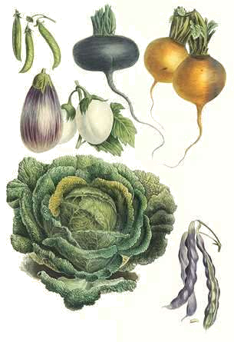  VEGETABLES  ASSORTED | Area Planted (in has) | 18
 | Area Harvested in has | 18
 | Production in M.T. | 55
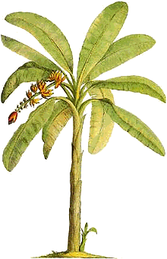    BANANA | Area Planted in has | 210
 | Area Harvested in has | 210
 | Production in M.T. | 630

Table 1.9 Agricultural Crop Production, Mapun, Tawi-Tawi, 2003 (DAF Report)
  CROPS | Area Planted  (in Has) | Production  (M.T.) | No. of  Farmers  Served
COCONUT | No data | 14,000
CORN | 50 | 36 | 72
CASSAVA | 378 | 263 | 535
VEGETABLES | 10 | 18 | 112
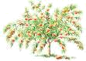  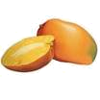  FRUIT TREES | 52 | 168 | 208
BANANA | 40 | 630 | 60
  RICE | 70 | 101 | 80

- Post Harvest Facilities

Due to lack of funds, there are limited post harvest facilities existing in the municipality. It has only one (1) rice power tiller serving the farmers. The Department of Agriculture and Fisheries has also provided one (1) solar drier and one (1) warehouse for the seaweeds farmers.

- Irrigation System

The National irrigation Administration has started a communal irrigation project at Sapah Lake. The progress of construction that has started in 1992 under the previous administration has been slow because of lack of heavy equipment and delay in fund releases. Currently, the present local chief executive is implementing a new irrigation project funded by DA-USAID. When completed, Sapah Lake would yield an estimated 8,000 cavans of rice annually.
In addition, DAF has established two (2) municipal agricultural nurseries, one (1) barangay nursery, and two (2) Farm Centers. It has implemented projects on Ginintuang Ani for Rice and Hybrid Rice Techno Demo Fair utilizing 5 Agricultural Technicians covering 3 barangays per project.
Mapun has two (2) dealers of agricultural inputs. They are: Cagayan Enterprises and Mapun Commercial Center
There also some civil society organizations organized in the agriculture sectors, namely: 16 Farmers' Association with 412 farmer-members; 11 Rural Improvement Clubs with 26members; 8 4-H Clubs with 248 members; 13 Fisher folks' Association with 332 members; and NDC Integrated Credit Cooperative with 100 members.
There are no logging concessions in the area because the timber standing is minimal and non-commercial species.
Meanwhile, forests in the island are of the dipterocarp mangrove type

- Livestock and Poultry

Livestock and poultry raising are more of backyard industries. Cattle are principally used as work animals for the farms and are slaughtered only on rare occasions such as wedding, death and birthday. It is interesting to note that as of 2001, a cattle is slaughtered only if it is lame or lazy to do farm work. Beef is usually bought in Sandakan, Malaysia, which is nearer than Bongao or Zamboanga.

Likewise, local supply of chicken eggs is not enough to meet the demand requirements. Unmet demand is met by supply from the nearest body of land, the town of Sandakan, Sabah.

Table 2.0 Livestock and Poultry Production, Mapun, Tawi-Tawi, 2001 (DAF Report)
SPECIES | 2000 | 2001 | 2002
Specie: Livestock
  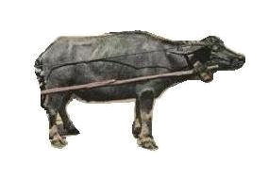  Cattle | 3,818 | 3,359 | 3,818
Carabao | 9 | 9 | 10
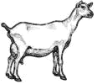  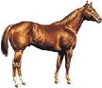  Goat | 1,357 | 884 | 1,417
Horse | 68 | 61 | 69
  Swine | 131 | 111 | 131
  Dog | 299 | 423 | 299
Specie: Poultry
  Chicken | 8,010 | 7,319 | 8,220
  Ducks | 220 | 244 | 235

F i s h e r y a n d A q u a t i c R e s o u r c e s
ô
ô

- Fishing Grounds and Fish Production

The DAF report in 2002 indicated that fish production in Mapun for the year 2001, to include all species caught and to include sustenance and deep-sea fishing is 1,238 metric tons.
Table 2.1 Fish Production, Mapun, Tawi-Tawi, 2000-2001 (DAF Report)
SPECIES OF FISH CAUGHT | 2000 | 2001
Assorted Fishes | 1,000 | 1,238

Based on informal surveys with the fisher folks and local fish dealers, it has been estimated that the fishing grounds of Mapun yield an annual fish catch or production of around 5,000 tons. So rich are its fishing grounds that fishing boats from as far as Navotas, Manila and Palawan and Cebu regularly come to Mapun to catch fish. Other aquatic products such as sea cucumber, lobster and chambered nautilus abound in the surrounding seas. Agar-agar or seaweeds, to this day however, has remained an untouched business venture. Attempts to grow this crop in Mapun proved to be futile. Among the reasons cited for the failure are high salinity and absence of strong currents in the area.

Post harvest facilities for fishing like fish landing ports are equally important for easy mobilization of marine products and fisher folks. There is a need to improve existing facilities for efficient service.

C o m m e r c e a n d I n d u s t r y

There are no manufacturing establishments in the municipality.
Next to copra production and fishing as chief sources of livelihood is retail and wholesale trading.
There is Tabuh-tabuh (market) system where the business right for a specified area in a barangay is awarded to operator who manages the once-a week market. Food products such as seafood, fresh fish, dried fish, fruits and vegetables, live chicken, and other items such as native mats and baskets are brought in from different barangays to this market.
Most notable of these markets is the Tabuh Sabtu (Saturday Market) where regular native cockfighting (without knife) is held. Tabuh Salasa (Tuesday Market) remains a popular destination for many residents.

T o u r i s m

- Tourist Attractions (Natural and Man-made)

There are 26 mountains on the island, the highest peak being Mt. Liran (1,105 ft. above sea level), which is sprawled over the barangays of Guppah, Duhul Batu and Sapah. But the interior of the island is a vista of "low and graceful green hills and cones rising from sloping valleys and miniature plains" that would be in itself a tourist attraction. -Found some 40 feet above sea level, the Tow Lakes are nearly perfect circles, separated only by a few meters of solid rock is one scenic view that would also attract visitors once developed.
Mapun is also home for turtles. Turtles lay eggs in San Miguel Island, fondly called by the natives as Bangkawan.
White sandy beautiful beaches like Umus Beach, Billat Beach, Secret Beach, Raymond's Beach and Joker Beach offer colorful coral reefs for picnickers and scuba divers.
Mapun has three (3) lakes, namely, Lake Danao, Lake Singuang and Lake Sapah with areas about 24, 28 and 69 hectares respectively. Lake Danao and Lake Singuang are two freshwater crater lakes. Lake Sapah found near the center of the island is marsh-like and formed by the accumulation of rainwater over time and is approximately 69 hectares in area.
Jurata Bay, which was used as harbor by American warships and vessels during World War II, is one historic place and has an area of about 35 hectares with about 70 fathoms at its deepest. A crater bay whose seaward walls open to the sea that forms it.

- Tourist Accomodations

Mapun is a young local government unit in terms of development and progress. Tourists and visitors arriving in the island are usually accommodated in private houses in the absence of commercial accommodation facilities.

- Tourist Arrivals

Most visitors that come to Mapun are with official purpose. Many are representatives of donor institutions that come to the island by boat via Palawan. Occasionally when the weather is good, foreigners come and visit the beautiful beaches surrounding the island that are conducive for scuba diving.

- Accessibility
Mapun is reached from Zamboanga City by boat during good weather. There is no regular schedule for sea transportation; availability of transport facilities depends on the weather, volume of cargo and number of passengers. It is reached also passing thru Puerto Princesa, Palawan from Manila by airplane or boat, and then takes the regular transportation from Puerto Princesa to Mapun.
Communication facilities have been a difficulty when one is in Mapun. Commercial communication companies have not reached the area yet. The local government looks forward to the availability of fast communication facilities that would make information dissemination easier and faster.

- Traditional Cultural Activities
Mapun is rich in culture and tradition. The local government plans to revitalize and preserve the traditional arts and culture of the Jama Mapun. This has been shown in dances and rituals done during Muslim and municipal-wide festivities. The youth has also been trained and developed to love and preserve the culture of his ancestors even if they are in other places.
- LGU Income from and Services for Tourism
As shown in its revenue report, the local government of Mapun has not generated income out of tourism. Everything is generously provided for free whenever visitors come to visit the island, for official or personal reasons.
The local government has still to plan its tourism development to contribute to the increase of local revenue that would finance development undertakings.
The creation of a Tourism Development and Promotion Board, a novel move for Mapun, is an attempt to initiate the strategy of using Mapun's natural beauty and tourism potentials in the quest for progress and development.

E c o n o m i c S e r v i c e s
There is no bank of any type in the Municipality of Mapun.
The Notre Dame of Cagayan Integrated Cooperative, Inc., in existence for the past 22 years, is one of 2 cooperative institutions that cater to banking needs of member residents, accepting deposits and giving out loans. The other cooperative is the Goodwill Multi-Purpose Cooperative at Liyubud.

C H A P T E R V
S O C I A L S E R V I C E S

H E A L T H

Table 2.2 Crude Birth Rate (CBR), Crude Death Rate (CDR), Maternal Mortality Rate (MMR), Neonatal Mortality Rate (NMR), Infant Mortality Rate (IMR). Department of Health, Municipality of Mapun. 2000-2003. 2005-2006.
Indicator | 2002 | 2003 | 2004 | 2005 | 2006
Crude Birth Rate  (CBR) | 14.1 | 25.5 | 10.2 | 15.8 | 13.4
Crude Death Rate  (CDR) | 2.8 | 2.6 | 3.5 | 4.4 | 2.14
Maternal Mortality Rate  (MMR) | 4.4 | 0 | 6.2 | 2.6 | 0
Infant Mortality Rate  (IMR) | 2.17 | 3.2 | 7.1 | 4.7 | 0.4
Note: Data above is per 1,000 live births

C r u d e B i r t h R a t e (CBR)

The latest data on Crude Birth Rate (CBR) of Mapun registered at 13.4 number of live births per 1,000 population in 2006. This translates to a downward trend starting from the recorded year of 2003 where CBR was at its highest rate.

In 2003 CBR rose by as much as 81% from 14.1 in the previous year to 25.5. This denotes an increase of 11.4 births per 1,000 of the population. In the following year however of 2004, CBR dropped by as much as 60% to 10.2.

The trend of CBR from 2002-2006 does not denote a constant rise nor drop in percentage but a mix of alternate rise and drop in CBR.

C r u d e D e a t h R a t e (CDR)

The latest data on Crude Death Rate (CDR) of Mapun registered at 2.14 number of deaths per 1,000 population in 2006. This is the lowest CDR among all the recorded years from 2002-2006.

Between the three periods 2003-2005, CDR showed a constant rise until 2005 where it registered the highest at 4.4 number of deaths per 1,000 of the population. CDR trend for the past five years generally show a range of 2.5 – 3.0 number of deaths per 1,000 of the population.

M a t e r n a l M o r t a l i t y R a t e (MMR)

Maternal Mortality Rate (MMR) in the Municipality of Mapun has been consistently erratic. Actual figures however may vary since this data is only based on reported cases. It is of note that in particular years 2003 and 2006 where MMR is zero (0), this is followed or preceded by an MMR of 4.4, 6.2, and 2.6 respectively in the other recorded years.

I n f a n t M o r t a l i t y R a t e (IMR)

Infant Mortality Rate (IMR) in the municipality for the past five years shows an upward then downward trend. Actual figures however may vary since this data is only based on reported cases. From 2002-2004 for instance, IMR shows a constant rise wherein 2004 had the highest recorded IMR in the municipality of 7.1. The following years show a constant drop to 4.7 in 2005 then 0.4 in 2006.

T o t a l F e r t i l i t y R a t e (TFR)

Baseline Survey of 500 randomly selected respondents from key barangays in the municipality conducted by the UNFPA Program this first quarter of 2007 shows that Total Fertility Rate (TFR) in Mapun is 2.2. This is the lowest statistic in the entire Tawi-Tawi province covered by the survey. Compared with other municipalities that reach the 5-6 mark, the report signifies that people in Mapun are more aware and conscious of family size planning.

M o r t a l I t y & M o r b I d I t y b y L e a d I n g C a u s e s , A g e a n d S e x

Mortality by Leading Causes, Age and Sex
Department of Health, Municipality of Mapun, 2006.

 | Age  <1 |  | Age  1-4 |  | Age  5-14 |  | Age  15-49 |  | Age  50-60 |  | Age  65+ |  | TOTAL |  | Deaths w/  Medical  Attendance
Cause | M | F | M | F | M | F | M | F | M | F | M | F | M | F | TOTAL
Old Age |  |  |  |  |  |  |  |  |  |  | 2 | 4 | 2 | 4 | 6
CVA |  |  |  |  |  |  |  | 1 | 1 |  | 1 | 1 | 2 | 2 | 4
PTB |  |  |  |  |  |  |  | 1 | 2 |  | 1 |  | 3 | 1 | 4
Intra-uterine Fetal Birth (Stillbirth) |  | 3 |  |  |  |  |  |  |  |  |  |  | 0 | 3 | 3
Myocardial Infection |  |  |  |  |  |  |  |  | 2 | 1 |  |  | 2 | 1 | 3
Pneumonia | 1 | 1 |  |  |  |  |  |  |  |  |  |  | 1 | 1 | 2
Severe Anemia |  |  |  |  |  |  |  | 2 |  |  |  |  | 0 | 2 | 2
Asphyxia Strangulation |  |  |  |  |  |  | 2 |  |  |  |  |  | 2 | 0 | 2
Cancer, Breast |  |  |  |  |  |  |  | 1 |  |  |  |  | 0 | 1 | 1
Cancer, Bone |  |  |  |  |  |  |  |  |  |  |  | 1 | 0 | 1 | 1
Abdominal Colic |  |  | 1 |  |  |  |  |  |  |  |  |  | 1 | 0 | 1
Acute Gastroenteritis |  |  |  |  |  |  |  |  |  |  |  | 1 | 0 | 1 | 1
Peptic Ulcer, Bleeding |  |  |  |  |  |  |  |  | 1 |  |  |  | 1 | 0 | 1
Acute Renal Failure |  |  |  |  |  |  | 1 |  |  |  |  |  | 1 | 0 | 1
Hacking Wound |  |  |  |  |  |  | 1 |  |  |  |  |  | 1 | 0 | 1
Stabbed Wound |  |  |  |  |  |  |  | 1 |  |  |  |  | 0 | 1 | 1
Diabetes |  |  |  |  |  |  |  | 1 |  |  |  |  | 0 | 1 | 1
Anemia |  |  |  |  |  |  |  | 1 |  |  |  |  | 0 | 1 | 1
Premature Baby |  | 1 |  |  |  |  |  |  |  |  |  |  | 0 | 1 | 1
Neonatal Death |  | 1 |  |  |  |  |  |  |  |  |  |  | 0 | 1 | 1
Congenital Anomaly |  |  | 1 |  |  |  |  |  |  |  |  |  | 1 | 0 | 1
 | 1 | 6 | 2 | 0 | 0 | 0 | 4 | 8 | 6 | 1 | 4 | 7 | 17 | 22 | 39

Morbidity by Leading Causes, Age and Sex
Department of Health, Municipality of Mapun, 2006.

 | Age  <1 |  | Age  1-4 |  | Age  5-14 |  | Age  15-49 |  | Age  50-60 |  | Age  65+ |  | TOTAL
Cause | M | F | M | F | M | F | M | F | M | F | M | F | M | F | TOTAL
Pneumonia | 13 | 12 | 23 | 14 | 10 | 6 | 1 | 2 | 3 | 1 | 1 |  | 51 | 35 | 86
Hypertension |  |  |  |  |  | 1 | 5 | 12 | 19 | 30 | 5 | 6 | 29 | 49 | 78
Diarrhea | 4 | 7 | 12 | 11 | 3 | 4 |  | 2 | 2 |  |  |  | 21 | 24 | 45
TB Respiratory |  |  |  |  | 1 | 1 | 13 | 10 | 7 | 4 | 4 | 1 | 25 | 16 | 41
Influenza |  | 2 | 1 | 8 | 4 | 8 | 1 | 7 | 2 | 1 |  | 2 | 8 | 28 | 36
Malaria |  |  | 2 | 1 | 4 | 1 | 15 | 10 | 2 |  |  |  | 23 | 12 | 35
Bronchitis/Bronchiolitis | 1 | 2 | 3 | 4 | 2 |  |  | 4 |  |  |  |  | 6 | 10 | 16
Leprosy |  |  |  | 2 |  |  | 2 | 2 |  | 1 |  |  | 2 | 5 | 7
Diseases of the Heart |  |  |  |  |  |  | 1 |  |  |  | 1 |  | 2 | 0 | 2
Measles |  |  |  |  |  |  |  |  |  |  |  |  | 0 | 0 | 0
TB Meningitis |  |  |  |  |  |  |  |  |  |  |  |  | 0 | 0 | 0
TB Other Forms |  |  |  |  |  |  |  |  |  |  |  |  | 0 | 0 | 0
Malignant Neoplasm |  |  |  |  |  |  |  |  |  |  |  |  | 0 | 0 | 0
Chicken Pox |  |  |  |  |  |  |  |  |  |  |  |  | 0 | 0 | 0
Dengue Fever |  |  |  |  |  |  |  |  |  |  |  |  | 0 | 0 | 0
Cholera |  |  |  |  |  |  |  |  |  |  |  |  | 0 | 0 | 0
Typhoid and Paratyphoid |  |  |  |  |  |  |  |  |  |  |  |  | 0 | 0 | 0
Whooping Cough |  |  |  |  |  |  |  |  |  |  |  |  | 0 | 0 | 0
Syphillis |  |  |  |  |  |  |  |  |  |  |  |  | 0 | 0 | 0
Gonorrhea |  |  |  |  |  |  |  |  |  |  |  |  | 0 | 0 | 0
AIDS/HIV Infection |  |  |  |  |  |  |  |  |  |  |  |  | 0 | 0 | 0
 | 18 | 23 | 41 | 40 | 24 | 21 | 38 | 49 | 35 | 37 | 11 | 9 | 167 | 179 | 346

Top Ten Leading Causes of Mortality by Sex

Top Ten Leading Causes of Mortality in Males/100,000 Population

Table 2.5 Department of Health, Municipality of Mapun 2006
Cases | No. | Rate
PTB | 3 | 18%
Old Age | 2 | 12%
CVA | 2 | 12%
Myocardial Infection | 2 | 12%
Asphyxia Strangulation | 2 | 12%
Pneumonia | 1 | 6%
Abdominal Colic | 1 | 6%
Peptic Ulcer, Bleeding | 1 | 6%
Acute Renal Failure | 1 | 6%
Hacking Wound | 1 | 6%
Congenital Anomaly | 1 | 6%
 | 17 | 100%

Top Ten Leading Causes of Mortality in Females/100,000 Population

Table 2.6 Department of Health, Municipality of Mapun 2006
Cases | No. | Rate
Old Age | 4 | 18%
Intra-uterine Fetal Birth (Stillbirth) | 3 | 14%
CVA | 2 | 9%
Severe Anemia | 2 | 9%
PTB | 1 | 5%
Myocardial Infection | 1 | 5%
Pneumonia | 1 | 5%
Cancer, Breast | 1 | 5%
Cancer, Bone | 1 | 5%
Acute Gastroenteritis | 1 | 5%
 | 17 | 77%

Other causes of death that shares the same number of cases, which is only 1, are anemia, diabetes, stabbed wounds, premature baby, and neonatal death. These cases complete the total number of cases in female mortality.

Proportion of Children 0-5 Years Old Who Died to the Sum of Children Aged 0-5 Years Old

Department of Health, Municipality of Mapun 2006

Number of Children Aged 0-5 Years Who Died: 9
Number of Children Aged 0-5 Years: 1,597

In 2006, the total number of children aged 0-5 years who died are recorded at 9. Around 1,597 children fall under this age group during this particular year. This denotes that 0.56% of the total children under this age group died of diseases indicated at Table Mortality in the previous page.

Top Ten Leading Causes of Morbidity by Sex

Top Ten Leading Causes of Morbidity in Males/100,000 Population

Table 2.7 Department of Health, Municipality of Mapun 2006
Cases | No. | Rate
Pneumonia | 51 | 31%
Hypertension | 29 | 17%
TB Respiratory | 25 | 15%
Malaria | 23 | 14%
Diarrhea | 21 | 13%
Influenza | 8 | 5%
Bronchitis/Bronchiolitis | 6 | 4%
Leprosy | 2 | 1%
Diseases of the Heart | 2 | 1%
Measles | 0 | 0%
 | 167 | 100%

Top Ten Leading Causes of Morbidity in Females/100,000 Population

Table 2.8 Department of Health, Municipality of Mapun 2006
Cases | No. | Rate
Hypertension | 49 | 27%
Pneumonia | 35 | 20%
Influenza | 28 | 16%
Diarrhea | 24 | 13%
TB Respiratory | 16 | 9%
Malaria | 12 | 7%
Bronchitis/Bronchiolitis | 10 | 6%
Leprosy | 5 | 3%
Diseases of the Heart | 0 | 0%
Measles | 0 | 0%
 | 179 | 100%
Proportion of Children 0<7 Years Old Who are Malnourished to the Sum of Children Aged 0<7 Years Old

Table 2.9 Operation Timbang Summary Report, Department of Health, Municipality of Mapun 2006

Classification  of  Nutritional Status | Age Group |  |  | Total
Classification  of  Nutritional Status | 0-11 Mos.  <1 Yr. | 12-59 Mos.  1<5 Yrs. | 60-83 Mos.  5<7 Yrs. | No. | Percent
SEVERELY UNDERWEIGHT  3rd Degree Malnourished | 23 | 32 | 4 | 59 | 2%
MODERATELY UNDERWEIGHT  2nd Degree Malnourished | 78 | 341 | 82 | 501 | 19%
MILDLY UNDERWEIGHT  1st Degree Malnourished | 113 | 615 | 187 | 915 | 35%
NORMAL | 163 | 687 | 220 | 1070 | 41%
OVERWEIGHT | 31 | 42 | 10 | 83 | 3%
TOTAL | 408 | 1717 | 503 | 2628 | 100%

Total Number of  Barangays:  15 | Total Number of Barangays with Operation Timbang: 15 | Percent Coverage: 100%
Estimated No. of  Children 0<7 Years Old: 4,919 | Actual No. of  Children Weighed:  2,628 | Percent Coverage: 53.42%

Operation Timbang 2006 under the Philippine Nutrition Programme weighed a total of 2,628 number of children aged 0<7 years old. This constitutes 53.42% coverage from the total estimated number of children under this age group calculated at 4,919. Among the total weighed number of children, 56% are malnourished ranging from mild to severe. A large portion of these however falls under the 1st degree at 35%, followed by moderately underweight (2nd degree) at 19% and lastly, severely underweight (3rd degree) at 2%.

Percentage of Infants with Low Birth Weight 

Based on the Table above, a total of 214 infants under the age group 0<1 year are considered underweight. This constitutes 52.45% of the total infant population. The largest portion falls under the mildly underweight class or 1st degree malnourished classification at 27.70%, followed by moderately underweight (2nd degree) at 19.11% and lastly, severely underweight (3rd degree) at 5.64%.

Percentage of Households with Access to Safe Water, Sanitary Toilets, Complete Basic Sanitation Facilities, and with Satisfactory Garbage Disposal

Table 3.0 Department of Health Municipality of Mapun
No. of Households with | 2004 | 2005 | 2006 | 2007  (1st-2nd Qtr)
Access to Safe Water Level 1 | 2,608 | 3,014 | 3,459 | 3,499
Access to Safe Water Level 2 | 47 | 49 | 54 | 57
Acess to Safe Water Level 3 | 0 | 0 | 0 | 0
Access to Safe Water Level 1-3 | 2,655 | 3,063 | 3,513 | 3,556
Sanitary Toilets | 802 | 802 | 850 | 858
Complete Basic Sanitation Facilities | 802 | 802 | 850 | 858
Satisfactory Garbage Disposal | 2,931 | 2,931 | 2,936 | 2,854
Total Households | 3,955 | 4,030 | 4,928 | 4,943

The percentage of households with access to safe water (level 1-3) falls to 65-71% for the past four years. The largest portion of safe water is attributed to level 1, which accounts for 98% for the last four years. Only 2% or less has access to level 2 safe water. Level 3 safe water has not been made available yet in the municipality.

The percentage of households with sanitary toilets and complete basic sanitation facilities remains relatively low in the municipality. From 2004-2007, an average of 24.57% of the household population has complete basic sanitation facilities and sanitary toilets. 2004 remains the year with highest percentage (27.18%) despite the increase in number of households from 802 to 858 in 2007. This is due to the fact that the increase in household population is greater than the increase in households with sanitary toilets.

The percentage of households with satisfactory garbage disposal is high in Mapun. From 2004-2007, an average of 86.39% of the household population has satisfactory garbage disposal. The year with highest percentage is 2004 with 99.32%. From this year to 2007 however, the number of households practicing satisfactory garbage disposal dwindled to 2,854 from 2,931.

Number of Health Personnel in Local Government Unit (LGU)

Table 3.1 Department of Health, Municipality of Mapun 2006
Health Personnel | Number
Doctors | 3
Registered Nurses | 7
Nutritionists | 1
Medical Technologists | 2
Dental Aides | 1
Non Technical | 11
Dentists | 1
Midwives | 4
Sanitary Inspectors | 1
Active BHWs | 71
Trained Birth Attendants | 37
Total | 139

A total of 139 health personnel deliver health care services for the Municipality of Mapun. The largest group comprises the barangay health workers, which account for 51% of the entire health worker population in the municipality. Trained birth attendants form the next largest group at 27%. The number of doctors and nurses remain low in the municipality for many years now, which only numbers 3 and 7 respectively.

Doctor to Population Ratio

1 Doctor : 8,214 People

Based on the Table of Health Personnel above, the total number of doctors in the municipality in 2006 is only 3. Estimated total population of Mapun in 2006 is calculated at 24,642. This translates to one doctor for every 8,214 people in the municipality.

Nurse to Population Ratio

1 Nurse : 3,520 People

Total number of registered nurses in the municipality in 2006 is 7.With an estimated total population of 24,642, this illustrates to one nurse for every 3,520 of the population.
Hospital Bed to Population Ratio

1 Hospital Bed : 986 People / Patients

The current total number of hospital beds available for patient use in Mapun’s only District Hospital is only 25. With an estimated total population of 24,642 in 2006, this translates to one hospital bed for every 986 of the population.

Health Center to Population Ratio

1 Health Center : 6,161 Population

The total number of health centers in the municipality in 2002 was 7. The number however declined to only 4 in 2006 and at present. Based on the estimated total population of 24,642 in 2006, this illustrates that a health center would have to cater for 6,161 of the population.
Percentage of Births Attended by Health Personnel 

Table 3.2 Department of Health, Municipality of Mapun 2006
Deliveries Attended by  Health Personnel | Number
Doctors | 0
Registered Nurses | 4
Midwives | 190
Trained Hilot | 72
Untrained Hilot | 29
Others | 0
Total | 295
Total Number of Livebirths | 295

In 2006, the Department of Health in the Municipality of Mapun recorded a hundred percent of birth deliveries attended by health personnel. The table above shows the total number of deliveries as attended by different health personnel in the municipality. Midwives comprise the largest attending group at 64% followed by trained hilots at 24%. Untrained hilots comprise the remaining 10% while the registered nurses only 1.4%.

Contraceptive Prevalence Rate

Table 3.3 Department of Health, Municipality of Mapun 2006
 | 2001 | 2002 | 2003 | 2004 | 2005
Contraceptive Prevalence  Rate (CPR) | 32.1% | 33.0% | 14.0% | 12.0% | 10.2%

Latest figure on contraceptive prevalence rate (CPR) in Mapun is 10.2% in 2005. The use of contraceptives in the municipality dramatically dropped in 2003 to 14% from 33% in the previous year. Since then CPR follows a downward trend until 2005.

E d u c a t i o n
- Literacy Rate
Literacy rate in Mapun is estimated at 50-60% only. The educational program in Mapun is complemented by the presence of primary and elementary schools by the Department of Education, while the Notre Dame, Mindanao State University - Tawi-Tawi College of Technology and Oceanography, and the Tawi-Tawi Academy run by the Seventh-Day Adventist Church provide secondary schools. In addition, the Mindanao State University also provides a two-year college education through its Extension Classes under the College of Arts and Sciences.
- Enrollment
Total Enrollment in Primary School by Sex
Latest enrollment figures of public primary and elementary schools for SY 2006-2007 (to include pre-schoolers) are:

Table 3.4A: Total Enrolment in Primary School by Grade Level and by Sex, DepEd, Mapun, Tawi-Tawi 2006-2007
Grade Level | Male | Female | Total
I | 857 | 766 | 1623
II | 485 | 458 | 943
III | 379 | 369 | 748
IV | 346 | 399 | 745
V | 294 | 364 | 658
VI | 232 | 279 | 511
Total | 2593 | 2635 | 5228

Table 3.4B: Total Enrolment in Primary School by Grade Level and by Sex (in Percentage), DepEd, Mapun, Tawi-Tawi 2006-2007
Grade Level | Male | Female | Total
I | 52.80% | 47.19% | 100%
II | 51.43% | 48.56% | 100%
III | 50.67% | 49.33% | 100%
IV | 46.44% | 53.55% | 100%
V | 44.68% | 55.31% | 100%
VI | 45.40% | 54.59% | 100%
Total | 49.59% | 50.40% | 100%

In grade levels I-III, the population of boys outnumbers the population of girls by as much as 128 in total number. Also, in each of these grade levels, the boys registered the highest enrolment compared to the girls.

In higher grade levels IV-VI, however, the girls outnumber the boys by as much as 170 in total number. Likewise, in each of these grade levels, the girls registered the highest enrolment compared to the boys.

In total, a minute difference of only 0.81% means that the female population in the primary levels of education outnumbers the male population by only 42 in its total enrolment population of 5,228.

Of the total population, 49.90% are males while 50.40% are females which denote a near 1:1 ratio. Previous data on enrolment figures in SY 2003-2004 illustrates a much closer ratio of 1:1 where male enrollees registered a total of 2,584 and the female enrollees registered a total of 2,589. This signifies that the right for primary education in the municipality is equal among the sexes.

- Dropout Rate
There has been no available record on the percentage of school dropouts. However, school reports said that pupils usually incur long absences during harvest season to participate in the activities. Most commonly, these absences become dropouts because the pupils lose interest in their studies due to failure to attend regularly their classes.
- No. of Teachers per School and by Sex
Based on the latest registered data of the Department of Education for the School Year 2006-2007, where 18 primary schools are sampled, the Municipality of Mapun has an average of 5-6 teachers per primary school with 83.50% of its total teacher population being females. Only 17 are males among the 103 total teacher population. This means that on the average of 5-6 teachers per primary school, one is a male professor while 4-5 are female instructors.

Another set of data recorded by the Department of Education on teachers classified by sex also shows the large role played by females as teachers:

Total Number of Teachers by Sex
Males 31 21.53%
Females 113 78.47%
Total 144 100%

The table below shows the composition of teachers and students in primary schools as classified by sex.

Table 3.5: Total Enrolment & No. of Teachers in Primary Schools by Sex and by School, DepEd, Municipality of Mapun, Tawi-Tawi 2006-2007

Name of Primary School | No. of Enrolment by Sex |  |  | No. of Teachers by Sex |  |  | No. of Special Teacher | No. of School Nurse | No. of Principal
 | Male | Female | Total | Male | Female | Total
Lupa Pula Pilot I-VI | 456 | 477 | 933 | 2 | 17 | 19 | 4 | 1 | 1
Annex  I-II | 31 | 41 | 72 | 0 | 2 | 2 | 0 | 0
Mahalu  I-VI | 99 | 133 | 232 | 0 | 6 | 6 | 1 | 1 | 1
Imam Saat  I-VI | 91 | 99 | 190 | 1 | 6 | 7 | 0 | 1
Tabulian  I-VI | 64 | 76 | 140 | 2 | 3 | 5 | 0 | 0
Boki  I-VI | 160 | 150 | 310 | 1 | 5 | 6 | 0 | 0 | 1
Pawan  I-VI | 96 | 93 | 189 | 1 | 4 | 5 | 0 | 1
Iruk-Iruk Primary  I-VI | 23 | 22 | 45 | 0 | 2 | 2 | 0 | 0
Tanduan  I-VI | 110 | 95 | 205 | 1 | 5 | 6 | 0 | 1 | 1
Sibuk  I-VI | 108 | 95 | 203 | 2 | 4 | 6 | 0 | 0
Kompang  I-VI | 94 | 78 | 172 | 1 | 4 | 5 | 0 | 0
Ummus  I-VI | 193 | 174 | 367 | 0 | 8 | 8 | 1 | 1 | 1
Sapah  I-VI | 151 | 127 | 278 | 1 | 5 | 6 | 1 | 1
Duhul Batu  I-VI | 146 | 151 | 297 | 1 | 5 | 6 | 0 | 0
Guppah  I-VI | 108 | 116 | 224 | 1 | 4 | 5 | 0 | 0
Batutay  I-VI | 69 | 69 | 138 | 1 | 1 | 2 | 0 | 0
Lubbak Parang  I-VI | 55 | 62 | 117 | 1 | 2 | 3 | 0 | 1
Tuan Balalun  I-VI | 68 | 45 | 113 | 1 | 3 | 4 | 0 | 0
Pre-School
Tanduan | 12 | 13 | 25
Pilot | 29 | 29 | 58
TOTAL | 2163 | 2145 | 4308 | 17 | 86 | 103 | 7 | 8 | 5

- Pupil to Teacher Ratio (Primary and Secondary)
Based on the latest data illustrated by the table above, the primary pupil to teacher ratio stands at 42 pupils: 1 teacher. A total of 4,308 primary students are handled by a total of 103 teachers.

However, pupil to teacher ratio improves to 39 pupils: 1 teacher when secondary level data is included. This can be attributed to the only three (3) existing secondary schools available in the municipality where a significant number of students do not pursue or continue the secondary level of education. Various reasons include: financial consideration of the student’s family, involvement in farm and fishing activities to increase family income, as well as family and community perception on education.

- Location and No. of Schools (Type and Conditions)
Mapun has one (1) Kindergarten School (Kiddie Evangelical School); nine (9) Primary Schools; eleven (11) Elementary Schools; three (3) High Schools; and, one (1) College Extension (MSU-TCTO).
There are also seven (7) Madrasah Schools in the municipality, in Barangays Tanduan, Duhul Batu, an Liyubud.
- Vocational / Technical Education & Manpower Trainings
Mapun has no technical schools that offer technical or vocational courses or manpower trainings. Skills trainings are usually conducted by non-government organizations for specific target clienteles as part of a program.
- NFE & ECD
Non-formal education is part of the services provided by the Department of Education. This is intended for adults who have not been in formal school during their school age and in order to provide them with skills trainings usually home based for women to give time to attend to their domestic chores while becoming productive.
While the schools only provide skills trainings, if there is enough funds for the program, some non-government organizations visit the barangays or the communities where there are high percentage of unproductive adults. These organizations provide income-generating programs.
- School Facilities
Many of the public schools lack the basic facilities like clinic, comfort rooms, water tanks, playground for children, home economics building or room, and many others. Only five (5) elementary schools have clinic facilities. Playgrounds of existing schools are not fully developed for physical fitness activities of schoolchildren.
Schools located in Pawan, Tabulian, Boki, Batutay, and Sikub need water catchments for depository.

Table below shows the availability of basic facilities like toilets that are not always found in many of the schools in the municipality.

Table 3.6 School Facilities in Primary Schools, DepEd, Municipality of Mapun, Tawi-Tawi 2006-2007
Name of Primary School | No. of School Buildings | No. of Toilets | No. of Desks | No. of Chairs | No. of H.E. Building | No. of Textbooks
L. Pula Pilot | 10 | 2 | 100 | 500 | 0 | 750
Annex | 1 | 0 | 30 | 10 | 0 | 70
Mahalu | 2 | 1 | 50 | 50 | 0 | 105
Imam Saat | 3 | 0 | 30 | 60 | 0 | 120
Tabulian | 2 | 0 | 35 | 45 | 0 | 90
Boki | 4 | 1 | 45 | 65 | 0 | 80
Pawan | 3 | 0 | 30 | 67 | 0 | 102
Iruk-Iruk | 1 | 0 | 10 | 25 | 0 | 55
Tanduan | 4 | 1 | 40 | 50 | 0 | 110
Sikub | 3 | 0 | 50 | 65 | 1 | 95
Kompang | 2 | 0 | 35 | 46 | 0 | 67
Umus | 6 | 1 | 55 | 70 | 1 | 150
Sapah | 3 | 1 | 40 | 55 | 0 | 130
Duhul Batu | 4 | 1 | 35 | 60 | 0 | 125
Guppah | 3 | 1 | 30 | 30 | 0 | 60
Batutay | 2 | 0 | 15 | 30 | 0 | 20
Lbk Parang | 2 | 0 | 14 | 25 | 0 | 35
Tn Balalun | 2 | 0 | 17 | 25 | 0 | 30

- Pupil to Classroom Ratio (Primary and Secondary)
Based on the latest data of the Department of Education, Municipality of Mapun, Pupil to Classroom Ratio stands at 1 classroom for every 36 students. This ratio is still considered in the ideal range since it promotes good interaction between an educator and a student. This ratio however does not illustrate the need for more classrooms and educators since a significant number of children still do not have access to education completion in the primary level, more so in the secondary level.

- By Percentage of School-Age Population by Age Group and Educational Attainment

More than 50% of the population with ages ranging from 6 years and above has reached at least elementary level. Only a few of this however has continued to secondary or high school. About 15% of the population never received formal education nor has any grade completed.

Table 3.7 Percent of School Age Population by Age Group and Educational Attainment, Municipality of Mapun, Tawi-Tawi, 1990 and 1995

Educational Attainment | Population 6 Years and Over
Educational Attainment | Population 6+ |  | Below 20 |  | 20+
Educational Attainment | 1990 | 1995 | 1990 | 1995 | 1990 | 1995
Population 6+ | 16,470 | 17,103 | 7,460 | 7,435 | 9,010 | 9,668
No Grade Completed | 17.4 | 19.3 | 13.4 | 14.0 | 20.7 | 23.4
Pre-School | 4.6 | 1.0 | 7.8 | 2.0 | 2.1 | 0.3
Elementary School | 58.4 | 57.1 | 64.7 | 67.2 | 53.1 | 49.4
High School | 13.0 | 15.2 | 11.6 | 14.1 | 14.1 | 16.1
Post Secondary | 0.3 | 0.1 | 0.2 | 0.0 | 0.4 | 0.2
College/Undergraduate | 3.2 | 3.8 | 1.2 | 2.1 | 4.9 | 5.2
Academic Degree Holder | 2.0 | 2.7 | --- | 0.0 | 3.6 | 4.8
Not Stated | 1.2 | 0.6 | 1.1 | 0.6 | 1.2 | 0.5

- No. of Day-Care Center and Day Care Workers
Of the 15 barangays, only four (4) have their Day-Care Centers. They are Barangays Duhol Batu, Lubbak Parang, Tabulian, and Lupa Pula.
Only two (2) day-care centers are functional with their respective Day-Care Worker. The other two (2) have no day-care worker thus no pre-school classes are provided to 4-6 years old children.
Below is a table the shows the Day-Care Centers, their respective available facilities, Day-Care Worker, and the number of sessions offered for pre-school children.
The remaining eleven (11) barangays have no day-care centers yet.

Table 3.8 List of Day-Care Centers and Location, DSWD Mapun, Tawi-Tawi
Barangay | Day-Care  Center | DCC Facilities | Number  of  Sessions | Number  of  Children | Day-Care  Worker
Lupa-Pula | Lupa Pula Day-Care Center | chairs, tables, charts, blackboard, science corner, mini library | 2 | 38 | Sharon Miranda
Duhol-Bato | Duhol Bato Day-Care Center | blackboard,  mini library, comfort room, chairs, tables and science corner | 1 | 25 | Sandrusia  Nur
Lubbak Parang | Lubbak Parang Day-Care Center | comfort room
Tabulian | Tabulian Day-Care Center

S p o r t s a n d R e c r e a t i o n

Softball and volleyball games, aside from basketball are popular among the people of the island. All barangays have makeshift volleyball courts where community folks, men and women, young and adults, play for physical fitness during leisure times.
A track and field oval, or more appropriately, an area is found in Barangay Mahalu. There are also two (2) billiard centers in town.
Schools need these physical fitness facilities for growing school children.
The local government also needs to develop sports development program in coordination with the barangays for physical development. Through sports development program, close coordination with community folks could be facilitated besides providing them with entertainment and physical development activities.
H o u s i n g a n d C o m m u n i t y D e v e l o p m e n t

Based on the average annual population growth rate in the past ten years, there has been an increase of more than 1% in the population of the Municipality of Mapun that need comfortable housing facilities.
At present, majority of the families in the coastal barangays love to build their houses made of light materials like lumber and bamboo along the coast where they and their married as well as unmarried children usually stay. Only those families with employed members either in the government or private sector or doing business have houses made of concrete materials situated usually in the hinterlands.
Most families construct their houses in their own lands although there is a few that build houses in the land owned by other people.
NSO 2000 data also shows that of the 3,492 total number of households, 70% has 5 or more members while only 30% has 4 members or below. Further, the registered average household size in the municipality as of 2000 is 6.3.
To date, the local government has yet to develop a housing program that would include designated resettlement and relocation areas. Besides, its meager local revenues could not provide low-cost housing for those constituents with low income and has been programmed to economic and other infrastructure initiatives.

- Land Use
The local government has not formulated its comprehensive land use plan yet. It has no zoning ordinances that would serve as basis for proper land use.
However, below are Land Tenure Improvement Data with Land Acquisition and Distribution (LAD) and Land Use Management and Development (LUMD) survey data with a target of 5,036 hectares land area that includes ARC area provided by the Department of Agrarian Reform- ARMM.
Table 3.9 Land Tenure Improvement Survey Table, Mapun, Tawi-Tawi
MAPUN | PROGRAM  CLASS | LAD  (HAS)  P1,335/ha | FUNDING  REQUIREMENT | LUMD  SURVEY  (HAS)  P2,992/ha | FUNDING  REQUIREMENT
CY 2004 | VOS | 300 | 400,500.00 | 300 | 897,600.00
 | VLT/DPS | 2,750 | 3,671,250.00 | 2,750 | 8,228,000.00
 | TOTAL | 3,050 | 4,081,750.00 | 3,050 | 9,125,600.00
 | VOS | 150 | 2,002,500.00 | 150 | 448,400.00
CY 2004 | VLTIDPS | 1,836 | 2,451,060.00 | 1,836 | 5,493,312.00
 | TOTAL | 1,986 | 2,651,310.00 | 1,986 | 5,942,112.00
GRAND TOTAL |  | 5,036 | P6,723,060.00 |  | P15,067,612.00

National Parameter Per Hectare
LAD P1,335.00
LUMD (Survey) P2,992.00
Total Funding Requirement
LAD P 6,723,060.00
LUMD (Survey) P15,067,712.00
Total P21,790,772.00

d
PNP
P u b l i c S a f e t y a n d W e l f a r e

- Protective Services
The Philippine National Police takes charge of maintaining peace and order in the municipality. However, it has a limited number of personnel that carry out its functions and responsibilities. Although there is harmonious relationship and good coordination that exists between the Philippine National Police and the local government, the police station cannot fully exercise its functions in both land and sea because of the limited number of-policemen.
Besides, PNP lacks the basic support facilities like fast land and sea transportation. It has no communication facilities to facilitate fast and coordinated action against lawbreakers.
The Police Station has no Women and Children's desk where abused women and children could go to.
The municipality has no fire stations and basic facilities to protect the communities from fire.

C H A P T E R V I
I N F R A S T R U C T U R E A N D U T I L I T I E S

T r a n s p o r t a t i o n

Land Transportation
- Roads and Bridges
Mapun has a 60 kilometer-circumferential road. Of this, only about 6 kilometers long is concretely paved while the rest are dirt and gravel roads. The local government needs additional funds in order to finish concreting this circumferential road to facilitate easy mobilization of goods and services. In 2001, there have been already 800 single motorcycles, 56 tricycles, and 62 other vehicles like multi-cabs, lorries, ford fiera, jeeps and light trucks that are passing through the roads of the island.
Likewise, the web of barangay roads that services the interior part of the fifteen composite barangays is all dirt roads. The municipality needs to improve its farm-to-market roads to allow efficient flow of goods and services from the farm to the center of the island.
Barangays Umus Mataha and Sapah need footbridges that would serve as pathways for people living in the area.
- Parking Areas
The Municipal Government of Mapun has still to designate areas for parking of vehicles especially in the wharf and other distinct areas where people usually await for transport.
- Transportation Facilities (Intra-Municipal)
There are several types of transportation facilities in Mapun. Single motorcycles running in the roads of the island along are 800. Ford Fiera jeeps are also in huge number at 62, used either for personal or commercial purpose. Other types of vehicles are: tricycles, owner-type jeeps, PUJ, light trucks and mini-bus.
There also few government vehicles, those that are used by the Department of Health, Municipal Government and Philippine Air force.
Table 4.0 Type and Number of Existing Land Transportation Facilities, Mapun, Tawi-Tawi, 2000
Type of Land Transportation Facilities | Number/Quantity
Tricycles | 8 (update estimated at 80, 2007)
Jeeps (Owner Type) | 7
Jeeps (Ford Fiera) | 62
Public Utility Jeepneys (PUJs) | 14
Light Trucks | 14
Mini Bus | 2 (0)
Motorcycles | 800
Type of Land Transportation Facilities | Number/Quantity
Government Vehicles:
Ambulance Car (DOH) | 1 (0)
Hi Lux Pick-Up (Municipal Government) | 1 (0)
Jeep (Philippine Air Force)
Air Transportation
There is no regular commercial flight to the island. A Philippine Air force plane comes once a month to bring the salary of military personnel stationed at Sapah Airstrip, the local headquarters of the Tactical Operations Squadrons-PAF. The airstrip is 3 km. in total length but only 1.5 km is capable of handling aircraft take-off and landings. Chartered small planes from Zamboanga City land on this airstrip once in a while. It is about 6 km from the Poblacion.
Sea Transportation
Six (6) sea vessels are regularly traveling from Mapun to Zamboanga and vice versa, when the weather warrants. It costs P800 for one to travel one way in 22-25 hours. These wooden-hulled vessels have an average tonnage of 120 MT with loading capacities of around 3,000 sacks of copra and 150 passengers.
Meanwhile, there is also another route that could be utilized in order to reach Mapun. One could pass through Manila then go to Palawan where eight (8) motor launches (alternately traveling from Mapun to Palawan and vice versa) are waiting at Brookes Point. Boat fare from Mapun to Brookes Point in Palawan is P500.00, traveling in 14-15 hours. Some 56 individual households have small motorboats in 16, 22, 45, 56 horsepower for persona( or commercial purposes. These small motorboats could travel from Mapun to Sandakan, Sabah in eight hours.
There are also existing 140 motorized pump boats with outriggers in the island. Fast sea craft like speedboat could ferry passengers to Sandakan, Malaysia from Mapun in 2 hours.

Mapun-Zamboanga Route and vice-versa via Motor Launches (M/L):

M/L Burhana M/L Mora M/L Adrian
M/L Trisha Mae M/L Sugar Diane M/L Isrin

Fare: Php 800 one-way adult fare
Php 400 one-way children’s fare
Php 640 one-way senior citizen fare

Mapun-Palawan Route and vice-versa (Brooke’s Point)

ML Tiradzna
ML Natalie

Fare: Php 500 one way adult fare
Php 250 one way children’s fare
Php 400 one way senior citizen fare

Table 4.1 Type and Number of Existing Sea Transportation, Mapun, Tawi-Tawi, 2006
Type of Transportation Facilities and Route | Number/Quantity
Motor Vessels (servicing Mapun-Zamboanga & vice-versa) | 6
Motor Launches (servicing Mapun-Palawan & vice-versa) | 8
Small Motor Boats (16 HP & 45 HP) | 56
Pump Boats | 140

- Ports/Wharves
At the eastern tip of the Poblacion is the only wharf in Mapun, with a surface area of 30 meters by 12 meters and depth of about 3-4 fathoms. This wharf is too small to accommodate big boats. It needs to be expanded in order to accommodate the existing motor launches and other water vessels operating and are coming in the area.
At low tide, water depth at the wharf measures only at about 2 fathoms. Large vessels have to drop anchor about a hundred meters away from the wharf.
Also, other barangays like Liyubud, Sikub, Umus Mataha and Sapah need to have ports for small bancas and motorboats to dock.

W a t e r R e s o u r c e s
- Water Sources and Treatment
There is a level II water system with source from Lake Singuang near the base of Mt. Binag. CAGAYAN DE TAWI-TAWI Water and Sanitation Association (CAWASA) operate the water system and provide water services to 3 barangays, serving 103 households.
Water distribution pipes have already been laid down for expansion to cover additional barangays like Boki, Tabulian, Pawan, Iruk-Iruk, Tanduan, Sikub and Kompang.
For areas not reached by the Waterworks System, there are a total of 106 deep and shallow wells, artesian wells, spring and rain collectors located in the different barangays from which majority of the residents rely for their water requirements. However, supply of rainwater cannot meet the demand of the households with the limited tanks and reservoir existing in the barangays.

- Flood Control, Drainage and Sewerage
Establishment of flood control and drainage system as well as seawalls and dikes are part of the long-term programs of the local government of Mapun. This specific infrastructure facility has not been given much attention in the past years because the place has not experienced flood as well as strong waves that would most likely destroy its forest and coastal environments.

C o m m u n i c a t i o n s
The Bureau of Telecommunications maintains a Telegraph Station in Mapun.
There is only one (1) post office serving the municipality.
Two [Six (6) SMART] calling centers are available in the island. Phone rates 6/minute for landline domestic calls and 9/ min for cell phone domestic calls, and P27 for international calls.
Seventeen (17) private-owned ICOM facilities exist in the municipality but these are for personal use only. Other types of radio facilities include single-side band or SSB usually used by boat owners and communication facilities of the Philippine Coast Guard, Philippine Air force, Philippine National Police, Department of Health and the Notre Dame of Cagayan de Tawi-Tawi. These facilities are available and could be used during emergency cases
Communication facilities are thru SMART and PLDT communication lines that can be accessed thru small communication stores in the island that depends on roof satellites. Good reception however depends on good weather conditions. A cellular site tower powered by Smart is erected recently in the island providing the locals communication access through the use of cell phones. Postal and telegraph services are provided by the municipal post office. (Fax) and photocopying services are also available on the island.

E n e r g y a n d E l e c t r i f i c a t i o n
Two (2) units of 250 KVA Dale Perkins Engines of Cagayan de Sulu Electric Cooperative, Inc (CASELCO) provide light and power from 6 Pm to 1:30 Am every night. There is no power supply from CASELCO during daytime.
In 2001, CASELCO has served 666 consumers/members per information gathered from NEA, Quezon City.
The existing power supply can only serve limited households. Providing power supply services to other communities would require additional facilities and equipment.
C H A P T E R V I I
A D M I N I S T R A T I V E M A C H I N E R Y & R E L A T E D I N S T I T U T I O N S

A d m i n i s t r a t i v e O r g a n i z a t i o n a n d M a n a g e m e n t

- Elected Officials
Mayor Nickerson L. Tan, who is in his third term, heads the local government unit. The Office of the Mayor serves as the executive body that provides the overall supervision and direction of the affairs of the local government.
With him is Vice Mayor Kennedy Muksin who is on his second term. Vice Mayor Muksin heads the legislative body of the local government unit.
The Sangguniang Bayan, a once male dominated body, is now composed of four females and six males.
The President of the Association of Barangay Chairmen (ABC) and the President of the Sangguniang Kabataan (SK), who are ex-officio SB members, are also both males.
Below is the list of Elected Municipal Officials of Mapun, Tawi-Tawi:

MUNICIPAL OFFICIALS
MAPUN, TAWI-TAWI
AS OF July 19, 2007

HON. NICKERSON L. TAN
Municipal Mayor

HON. KENNEDY H. MUKSIN
Municipal Vice-Mayor

SANGGUNIANG BAYAN MEMBERS:

- HON. ARMENDRA E. YARRADA
- HON. PILARICA E. SARAIL
- HON. GINGER RAY T. LAO
- HON. MANDING I. NASIL
- HON. JULHARI IBRAHIM
- HON. ANONG KUYUNG
- HON. NURHAMSA A. DIAZ
- HON. NURHAMSAR KIRAM
- HON. JULIAN J. LIM, JR. LIGA President
- HON. GENRHEY J. TAN SK FEDERATION President

The Municipality of Mapun is composed of fifteen barangays. Below is the list of barangays and their respective elected barangay chairpersons:
Table 4.2 List of Barangays and Barangay Chairperson, Mapun, Tawi-Tawi, 2007
Names of Barangays | Respective Barangay Chairpersons
Liyubud | Jocksin M. Tan
Lupa Pula | Rodolfo A. Bringas
Mahalu | Gayu Gubih
Lubbak Parang | Kajah I. Saharan
Boki | Ramlie J. Mula
Pawan | Sarial N. Asaral
Irok-Irok | Hji. Ajid U. Muksin
Tanduan | Haldan L. Hendi
Sikub | Hamdan Sahibuddin
Kompang | Rusin N. Alsad
Tabulian | Jussin A. Abdulkahar
Sapah  ~ _ | Salal S. Bullod
Umus Mataha | Julian J. Lim, Jr.
Duhol Bato | Madtaha A. Madsarani
Guppah | Wilborne B. Tusin

- Appointive Officials
As mandated by the Local Government Code, there are eight administrative departments in the local government. They are: Office of the Secretary to the Sangguniang Bayan; Office of the Municipal Treasurer; Office of the Municipal Assessor; Office of the Municipal Accountant; Municipal Budget Office; Municipal Planning and Development Office; Office of the Municipal Engineer; and Local Civil Registry Office. The Municipal Administrative Officer and Human Resource Management Officer are under the Office of the Mayor.
The Municipal Treasurer is under the Department of Finance and supervised by the Provincial Treasurer. He submits his periodic reports to the Provincial Treasurer. Likewise, the Provincial Assessor supervises the Municipal Assessor. Municipal Budget Officer is under the Department of Budget and Management who is directly supervised by the Provincial Budget Officer. The Local Civil Registrar on the other hand submits his reports to the National Statistics Office, the agency that supervises it with an office in the province. Other departments are directly under the LGU. However, all of these offices are administratively reporting to the local chief executive and form part of the local government unit.
Below is the list of mandated offices in the local government with their heads:
Municipal Treasurer | - Mr. Husin A. Nami
Municipal Assessor | - Mrs. Habiba I. Lim
Municipal Accountant | - Mr. Ahmad T. Soon
Municipal Budget Officer | - Mrs. Adoracion A. Anoos
Municipal Administrator | - Mr. Nelson I. Lim
Municipal Engineer | - Engr. Gappal Buhara
Municipal Civil Registrar | - Mr. Paul Atilano
Acting MPDC / SB Secretary | - Arthur S. Guerzon
- Civil Society Organization (CSO)
The List of Local CSOs taken from the Office of the Department of Interior and Local Government shows that there are 28 CSOs existing in Mapun. Seven (7) of these are accredited by the Sangguniang Bayan.
The Philippine Development Assistance Program, Inc. (PDAP), a non-government organization, is deep into its livelihood assistance program in Mapun.
The Philippine-Canada Local Government Support Program (PC-LGSP) and World Wildlife Fund (WWF) have recently entered into the local development program.
- Fiscal Administration
Local Income
In 2002, Mapun has a total income of 23,855.150.00. Of this, 97% comes from its Internal Revenue Allotment (IRA) and only 3% is generated locally from business permits and licenses, real property tax, marriage licenses, market receipts and fees. There is a need to educate the people to pay taxes. Likewise, the local revenue code has to be updated in order to improve revenue generation.
The Summary of Municipal Income in 2002 is as follows with total revenues of P23,855,150:
Internal Revenue Allotment | P23,374,496
Business Permits & Licenses | 142,234
Real property Taxes | 47,870
Community Tax Certificates | 18,000
Weight and Measure | 3,050
Marriage Licenses | 2,000
Receipts from Market | 25,000
Secretarial fees | 42,500
Fisheries | 200,000
Total REVENUES | P23, 855,150
LGU expenditure
EXPENDITURES for Personal Services | P10,952,726.20
Maintenance and Other Operating Expenses | 7,043,799.80
To 20% Development Fund | 4,674, 899.20
To 5% Calamity Fund | 1,168,724.80
Aid to Barangays | 15,000.00
Total EXPENDITURES | P23, 855,150.00

20% Development Fund

Mapun is classified as a 6th class municipality. The 20% development fund of the local government is commonly used for improvement of infrastructure facilities in order to make daily lives of the people in the different barangay easier and mobilization of goods and services faster. However, responding to the people's needs has been limited due to limited funds; the LGU depends so much on its Internal Revenue Allocation. There is still a need to mobilize the finance department of the local government in order to improve revenue collection for additional resources for efficient service delivery.

V I I I
A N N E X E S

Table 1.1 Mapun Land Area and Land Use Category
Land Use Category | Land Area
Land Use Category | Hectares (ha) | Percentage (%)
Agriculture | 6,270 | 50.89
Potential Agricultural Land | 5,540 | 44.97
Forestland | 4 | .03
Lakes, Swamps, and Marshes | 121 | .98
Grazing and Pasture Lands | 285 | 2.31
Inland Fishery Area | 10 | .08
Settlements Area | 90 | .73
Fishing Ground* | Mapun Sea | ***
Total | 12,320 | 99.99
*Area of Fishing Ground not included in number data

Table 1.2 Population of Mapun Municipality, Integrated Provincial Health Office (IPHO), Tawi-Tawi
Year | Population | Population Growth
2000 | 22,011 (NSO) | Base Year
2001 | 22,429 | 418
2002 | 22,855 | 426
2003 | 23,290 | 435
2004 | 23,732 | 442
2005 | 24,183 | 451
2006 | 24,643 | 460
2007 | 25,111 | 468
2008 | 25,588 | 477

Table 1.3 Mapun Total Population and Growth Rate

Year | Population | Average Annual  Population Growth
1990 | 19,372 | 0.12%
1995 | 20,716 | 1.38%
2000 | 22,011 | 1.25%

Graph 1.1: Population Pyramid, Municipality of Mapun, NSO 2000.

Table 1.4 Total Population by Sex and Age Group, Municipality of Mapun, Tawi-Tawi, NSO 2000

Age Group | Female | Male | Both Sexes
All Ages | 11,164 | 10,847 | 22,011
Under 1 | 248 | 286 | 534
1-4 | 1,272 | 1,274 | 2,546
5-9 | 1,638 | 1,569 | 3,207
10-14 | 1,471 | 1,396 | 2,867
15-19 | 1,313 | 1,208 | 2,521
20-24 | 999 | 997 | 1,996
25-29 | 863 | 831 | 1,694
30-34 | 582 | 583 | 1,165
35-39 | 672 | 594 | 1,266
40-44 | 473 | 464 | 937
45-49 | 466 | 473 | 939
50-54 | 323 | 335 | 658
55-59 | 279 | 239 | 518
60-64 | 175 | 221 | 396
65-69 | 142 | 137 | 279
70-74 | 116 | 114 | 230
75-79 | 74 | 63 | 137
80 and over | 58 | 63 | 121
0-17 | 5,415 | 5,264 | 10,679
18 and over | 5,749 | 5,583 | 11,332
Table 1.5 Total Population, Household Population, Number of Households by Barangay, Municipality of Mapun, Tawi-Tawi, NSO 2000

Barangay | Total Population | Household Population | Number of Households
Boki | 2,096 | 2,096 | 332
Duhul Batu | 1,322 | 1,322 | 225
Kumpang | 618 | 618 | 104
Pawan | 1,228 | 1,228 | 179
Sikub | 1,236 | 1,236 | 195
Tabulian | 1,045 | 1,045 | 178
Iruk-Iruk | 804 | 804 | 116
Guppah | 1,961 | 1,961 | 322
Liyubud | 2,680 | 2,680 | 411
Upper Lupah Pula | 1,163 | 1,155 | 167
Lubbak Parang | 776 | 776 | 132
Mahalu | 2,162 | 2,162 | 322
Sapah | 1,720 | 1,716 | 282
Tanduan | 1,047 | 1,047 | 160
Umus Mataha | 2,153 | 2,153 | 367
TOTAL | 22,011 | 21,999 | 3,492

Graph 1.2 Total Population by Barangay, Municipality of Mapun, Tawi-Tawi, NSO 2000

Table 1.6 Total Population and Number of Households Distributed in Urban and Rural Areas, Municipality of Mapun, Tawi-Tawi, NSO 2000

Classification | Total Population | Number of Households
URBAN | 3,843 | 578
RURAL | 18,168 | 2,914
TOTAL | 22,011 | 3,492

Graph 1.3 Population by Urban and Rural Distribution , Municipality of Mapun, Tawi-Tawi, NSO 2000

Table 1.7 Environmental Health Report, DOH, Mapun, Tawi-Tawi, 2003
Nature of Data | 2000 |  | 2001 | 2002 | 2003
1. No. of HH with sanitary toilets | 796 |  | 801 | 837 | 840
2. No. of HH with satisfactory garbage disposal | 2,696 |  | 2,698 | 2,748 | 3,101
3. No. of HH with complete basic sanitation facilities | 383 |  | 385 | 398 | 405
4. No. of Food establishments | 17 | 17 |  | 100 | 103
5. No of Food establishments with sanitary permit | 17 | 17 |  | 100 | 103
6. No. of Food Handlers | 26 | 26 |  | 65 | 70
7. No. of Food Handlers with Health Certificates | 26 | 26 |  | 65 | 70

Table 1.8 Crop Production, Mapun, Tawi-Tawi, 2001
CROPS | DETAILS | 2001
PALAY | Rainfed Lowland/update | 50
 | Area Planted (in has) | 50
 | Area Harvested (in has) | 50
 | Production (in M.T.) | 100
CORN  (YELLOW) | Area Planted (in has) | 30
 | Area Harvested in has | 30
 | Production in M.T. | 36
CASSAVA | Area Planted in has | 263
CASSAVA | Area Harvested in has | 263
CASSAVA | Production in M.T. | 2,367
VEGETABLES  ASSORTED | Area Planted (in has) | 18
 | Area Harvested in has | 18
 | Production in M.T. | 55
BANANA | Area Planted in has | 210
 | Area Harvested in has | 210
 | Production in M.T. | 630

Table 1.9 Agricultural Crop Production, Mapun, Tawi-Tawi, 2003 (DAF Report)
CROPS | Area Planted  (in Has) | Production  (M.T.) | No. of  Farmers  Served
COCONUT | No data | 14,000
CORN | 50 | 36 | 72
CASSAVA | 378 | 263 | 535
VEGETABLES | 10 | 18 | 112
FRUIT TREES | 52 | 168 | 208
BANANA | 40 | 630 | 60
RICE | 70 | 101 | 80

Table 2.0 Livestock and Poultry Production, Mapun, Tawi-Tawi, 2001 (DAF Report)
SPECIES | 2000 | 2001 | 2002
Specie: Livestock
Cattle | 3,818 | 3,359 | 3,818
Carabao | 9 | 9 | 10
Goat | 1,357 | 884 | 1,417
Horse | 68 | 61 | 69
Swine | 131 | 111 | 131
Dog | 299 | 423 | 299
Specie: Poultry
Chicken | 8,010 | 7,319 | 8,220
Ducks | 220 | 244 | 235

Table 2.1 Fish Production, Mapun, Tawi-Tawi, 2000-2001 (DAF Report)
SPECIES OF FISH CAUGHT | 2000 | 2001
Assorted Fishes | 1,000 | 1,238

Table 2.2 Crude Birth Rate (CBR), Crude Death Rate (CDR), Maternal Mortality Rate (MMR), Neonatal Mortality Rate (NMR), Infant Mortality Rate (IMR). Department of Health, Municipality of Mapun. 2000-2003. 2005-2006.
Indicator | 2002 | 2003 | 2004 | 2005 | 2006
Crude Birth Rate  (CBR) | 14.1 | 25.5 | 10.2 | 15.8 | 13.4
Crude Death Rate  (CDR) | 2.8 | 2.6 | 3.5 | 4.4 | 2.14
Maternal Mortality Rate  (MMR) | 4.4 | 0 | 6.2 | 2.6 | 0
Infant Mortality Rate  (IMR) | 2.17 | 3.2 | 7.1 | 4.7 | 0.4
Note: Data above is per 1,000 live births

Mortality by Leading Causes, Age and Sex
Department of Health, Municipality of Mapun, 2006.

 | Age  <1 |  | Age  1-4 |  | Age  5-14 |  | Age  15-49 |  | Age  50-60 |  | Age  65+ |  | TOTAL |  | Deaths w/  Medical  Attendance
Cause | M | F | M | F | M | F | M | F | M | F | M | F | M | F | TOTAL
Old Age |  |  |  |  |  |  |  |  |  |  | 2 | 4 | 2 | 4 | 6
CVA |  |  |  |  |  |  |  | 1 | 1 |  | 1 | 1 | 2 | 2 | 4
PTB |  |  |  |  |  |  |  | 1 | 2 |  | 1 |  | 3 | 1 | 4
Intra-uterine Fetal Birth (Stillbirth) |  | 3 |  |  |  |  |  |  |  |  |  |  | 0 | 3 | 3
Myocardial Infection |  |  |  |  |  |  |  |  | 2 | 1 |  |  | 2 | 1 | 3
Pneumonia | 1 | 1 |  |  |  |  |  |  |  |  |  |  | 1 | 1 | 2
Severe Anemia |  |  |  |  |  |  |  | 2 |  |  |  |  | 0 | 2 | 2
Asphyxia Strangulation |  |  |  |  |  |  | 2 |  |  |  |  |  | 2 | 0 | 2
Cancer, Breast |  |  |  |  |  |  |  | 1 |  |  |  |  | 0 | 1 | 1
Cancer, Bone |  |  |  |  |  |  |  |  |  |  |  | 1 | 0 | 1 | 1
Abdominal Colic |  |  | 1 |  |  |  |  |  |  |  |  |  | 1 | 0 | 1
Acute Gastroenteritis |  |  |  |  |  |  |  |  |  |  |  | 1 | 0 | 1 | 1
Peptic Ulcer, Bleeding |  |  |  |  |  |  |  |  | 1 |  |  |  | 1 | 0 | 1
Acute Renal Failure |  |  |  |  |  |  | 1 |  |  |  |  |  | 1 | 0 | 1
Hacking Wound |  |  |  |  |  |  | 1 |  |  |  |  |  | 1 | 0 | 1
Stabbed Wound |  |  |  |  |  |  |  | 1 |  |  |  |  | 0 | 1 | 1
Diabetes |  |  |  |  |  |  |  | 1 |  |  |  |  | 0 | 1 | 1
Anemia |  |  |  |  |  |  |  | 1 |  |  |  |  | 0 | 1 | 1
Premature Baby |  | 1 |  |  |  |  |  |  |  |  |  |  | 0 | 1 | 1
Neonatal Death |  | 1 |  |  |  |  |  |  |  |  |  |  | 0 | 1 | 1
Congenital Anomaly |  |  | 1 |  |  |  |  |  |  |  |  |  | 1 | 0 | 1
 | 1 | 6 | 2 | 0 | 0 | 0 | 4 | 8 | 6 | 1 | 4 | 7 | 17 | 22 | 39

Morbidity by Leading Causes, Age and Sex
Department of Health, Municipality of Mapun, 2006.

 | Age  <1 |  | Age  1-4 |  | Age  5-14 |  | Age  15-49 |  | Age  50-60 |  | Age  65+ |  | TOTAL
Cause | M | F | M | F | M | F | M | F | M | F | M | F | M | F | TOTAL
Pneumonia | 13 | 12 | 23 | 14 | 10 | 6 | 1 | 2 | 3 | 1 | 1 |  | 51 | 35 | 86
Hypertension |  |  |  |  |  | 1 | 5 | 12 | 19 | 30 | 5 | 6 | 29 | 49 | 78
Diarrhea | 4 | 7 | 12 | 11 | 3 | 4 |  | 2 | 2 |  |  |  | 21 | 24 | 45
TB Respiratory |  |  |  |  | 1 | 1 | 13 | 10 | 7 | 4 | 4 | 1 | 25 | 16 | 41
Influenza |  | 2 | 1 | 8 | 4 | 8 | 1 | 7 | 2 | 1 |  | 2 | 8 | 28 | 36
Malaria |  |  | 2 | 1 | 4 | 1 | 15 | 10 | 2 |  |  |  | 23 | 12 | 35
Bronchitis/Bronchiolitis | 1 | 2 | 3 | 4 | 2 |  |  | 4 |  |  |  |  | 6 | 10 | 16
Leprosy |  |  |  | 2 |  |  | 2 | 2 |  | 1 |  |  | 2 | 5 | 7
Diseases of the Heart |  |  |  |  |  |  | 1 |  |  |  | 1 |  | 2 | 0 | 2
Measles |  |  |  |  |  |  |  |  |  |  |  |  | 0 | 0 | 0
TB Meningitis |  |  |  |  |  |  |  |  |  |  |  |  | 0 | 0 | 0
TB Other Forms |  |  |  |  |  |  |  |  |  |  |  |  | 0 | 0 | 0
Malignant Neoplasm |  |  |  |  |  |  |  |  |  |  |  |  | 0 | 0 | 0
Chicken Pox |  |  |  |  |  |  |  |  |  |  |  |  | 0 | 0 | 0
Dengue Fever |  |  |  |  |  |  |  |  |  |  |  |  | 0 | 0 | 0
Cholera |  |  |  |  |  |  |  |  |  |  |  |  | 0 | 0 | 0
Typhoid and Paratyphoid |  |  |  |  |  |  |  |  |  |  |  |  | 0 | 0 | 0
Whooping Cough |  |  |  |  |  |  |  |  |  |  |  |  | 0 | 0 | 0
Syphillis |  |  |  |  |  |  |  |  |  |  |  |  | 0 | 0 | 0
Gonorrhea |  |  |  |  |  |  |  |  |  |  |  |  | 0 | 0 | 0
AIDS/HIV Infection |  |  |  |  |  |  |  |  |  |  |  |  | 0 | 0 | 0
 | 18 | 23 | 41 | 40 | 24 | 21 | 38 | 49 | 35 | 37 | 11 | 9 | 167 | 179 | 346

Table 2.5 Department of Health, Municipality of Mapun 2006
Cases | No. | Rate
PTB | 3 | 18%
Old Age | 2 | 12%
CVA | 2 | 12%
Myocardial Infection | 2 | 12%
Asphyxia Strangulation | 2 | 12%
Pneumonia | 1 | 6%
Abdominal Colic | 1 | 6%
Peptic Ulcer, Bleeding | 1 | 6%
Acute Renal Failure | 1 | 6%
Hacking Wound | 1 | 6%
Congenital Anomaly | 1 | 6%
 | 17 | 100%

Table 2.6 Department of Health, Municipality of Mapun 2006
Cases | No. | Rate
Old Age | 4 | 18%
Intra-uterine Fetal Birth (Stillbirth) | 3 | 14%
CVA | 2 | 9%
Severe Anemia | 2 | 9%
PTB | 1 | 5%
Myocardial Infection | 1 | 5%
Pneumonia | 1 | 5%
Cancer, Breast | 1 | 5%
Cancer, Bone | 1 | 5%
Acute Gastroenteritis | 1 | 5%
 | 17 | 77%

Table 2.7 Department of Health, Municipality of Mapun 2006
Cases | No. | Rate
Pneumonia | 51 | 31%
Hypertension | 29 | 17%
TB Respiratory | 25 | 15%
Malaria | 23 | 14%
Diarrhea | 21 | 13%
Influenza | 8 | 5%
Bronchitis/Bronchiolitis | 6 | 4%
Leprosy | 2 | 1%
Diseases of the Heart | 2 | 1%
Measles | 0 | 0%
 | 167 | 100%

Table 2.8 Department of Health, Municipality of Mapun 2006
Cases | No. | Rate
Hypertension | 49 | 27%
Pneumonia | 35 | 20%
Influenza | 28 | 16%
Diarrhea | 24 | 13%
TB Respiratory | 16 | 9%
Malaria | 12 | 7%
Bronchitis/Bronchiolitis | 10 | 6%
Leprosy | 5 | 3%
Diseases of the Heart | 0 | 0%
Measles | 0 | 0%
 | 179 | 100%

Table 2.9 Operation Timbang Summary Report, Department of Health, Municipality of Mapun 2006

Classification  of  Nutritional Status | Age Group |  |  | Total
Classification  of  Nutritional Status | 0-11 Mos.  <1 Yr. | 12-59 Mos.  1<5 Yrs. | 60-83 Mos.  5<7 Yrs. | No. | Percent
SEVERELY UNDERWEIGHT  3rd Degree Malnourished | 23 | 32 | 4 | 59 | 2%
MODERATELY UNDERWEIGHT  2nd Degree Malnourished | 78 | 341 | 82 | 501 | 19%
MILDLY UNDERWEIGHT  1st Degree Malnourished | 113 | 615 | 187 | 915 | 35%
NORMAL | 163 | 687 | 220 | 1070 | 41%
OVERWEIGHT | 31 | 42 | 10 | 83 | 3%
TOTAL | 408 | 1717 | 503 | 2628 | 100%

Total Number of  Barangays:  15 | Total Number of Barangays with Operation Timbang: 15 | Percent Coverage: 100%
Estimated No. of  Children 0<7 Years Old: 4,919 | Actual No. of  Children Weighed:  2,628 | Percent Coverage: 53.42%

Table 3.0 Department of Health Municipality of Mapun
No. of Households with | 2004 | 2005 | 2006 | 2007  (1st-2nd Qtr)
Access to Safe Water Level 1 | 2,608 | 3,014 | 3,459 | 3,499
Access to Safe Water Level 2 | 47 | 49 | 54 | 57
Acess to Safe Water Level 3 | 0 | 0 | 0 | 0
Access to Safe Water Level 1-3 | 2,655 | 3,063 | 3,513 | 3,556
Sanitary Toilets | 802 | 802 | 850 | 858
Complete Basic Sanitation Facilities | 802 | 802 | 850 | 858
Satisfactory Garbage Disposal | 2,931 | 2,931 | 2,936 | 2,854
Total Households | 3,955 | 4,030 | 4,928 | 4,943

Table 3.1 Department of Health, Municipality of Mapun 2006
Health Personnel | Number
Doctors | 3
Registered Nurses | 7
Nutritionists | 1
Medical Technologists | 2
Dental Aides | 1
Non Technical | 11
Dentists | 1
Midwives | 4
Sanitary Inspectors | 1
Active BHWs | 71
Trained Birth Attendants | 37
Total | 139

Table 3.2 Department of Health, Municipality of Mapun 2006
Deliveries Attended by  Health Personnel | Number
Doctors | 0
Registered Nurses | 4
Midwives | 190
Trained Hilot | 72
Untrained Hilot | 29
Others | 0
Total | 295
Total Number of Livebirths | 295

Table 3.3 Department of Health, Municipality of Mapun 2006
 | 2001 | 2002 | 2003 | 2004 | 2005
Contraceptive Prevalence  Rate (CPR) | 32.1% | 33.0% | 14.0% | 12.0% | 10.2%

Table 3.4A: Total Enrolment in Primary School by Grade Level and by Sex, DepEd, Mapun, Tawi-Tawi 2006-2007
Grade Level | Male | Female | Total
I | 857 | 766 | 1623
II | 485 | 458 | 943
III | 379 | 369 | 748
IV | 346 | 399 | 745
V | 294 | 364 | 658
VI | 232 | 279 | 511
Total | 2593 | 2635 | 5228

Table 3.4B: Total Enrolment in Primary School by Grade Level and by Sex (in Percentage), DepEd, Mapun, Tawi-Tawi 2006-2007
Grade Level | Male | Female | Total
I | 52.80% | 47.19% | 100%
II | 51.43% | 48.56% | 100%
III | 50.67% | 49.33% | 100%
IV | 46.44% | 53.55% | 100%
V | 44.68% | 55.31% | 100%
VI | 45.40% | 54.59% | 100%
Total | 49.59% | 50.40% | 100%

Total Number of Teachers by Sex
Males 31 21.53%
Females 113 78.47%
Total 144 100%

Table 3.5: Total Enrolment & No. of Teachers in Primary Schools by Sex and by School, DepEd, Municipality of Mapun, Tawi-Tawi 2006-2007

Name of Primary School | No. of Enrolment by Sex |  |  | No. of Teachers by Sex |  |  | No. of Special Teacher | No. of School Nurse | No. of Principal
 | Male | Female | Total | Male | Female | Total
Lupa Pula Pilot I-VI | 456 | 477 | 933 | 2 | 17 | 19 | 4 | 1 | 1
Annex  I-II | 31 | 41 | 72 | 0 | 2 | 2 | 0 | 0
Mahalu  I-VI | 99 | 133 | 232 | 0 | 6 | 6 | 1 | 1 | 1
Imam Saat  I-VI | 91 | 99 | 190 | 1 | 6 | 7 | 0 | 1
Tabulian  I-VI | 64 | 76 | 140 | 2 | 3 | 5 | 0 | 0
Boki  I-VI | 160 | 150 | 310 | 1 | 5 | 6 | 0 | 0 | 1
Pawan  I-VI | 96 | 93 | 189 | 1 | 4 | 5 | 0 | 1
Iruk-Iruk Primary  I-VI | 23 | 22 | 45 | 0 | 2 | 2 | 0 | 0
Tanduan  I-VI | 110 | 95 | 205 | 1 | 5 | 6 | 0 | 1 | 1
Sibuk  I-VI | 108 | 95 | 203 | 2 | 4 | 6 | 0 | 0
Kompang  I-VI | 94 | 78 | 172 | 1 | 4 | 5 | 0 | 0
Ummus  I-VI | 193 | 174 | 367 | 0 | 8 | 8 | 1 | 1 | 1
Sapah  I-VI | 151 | 127 | 278 | 1 | 5 | 6 | 1 | 1
Duhul Batu  I-VI | 146 | 151 | 297 | 1 | 5 | 6 | 0 | 0
Guppah  I-VI | 108 | 116 | 224 | 1 | 4 | 5 | 0 | 0
Batutay  I-VI | 69 | 69 | 138 | 1 | 1 | 2 | 0 | 0
Lubbak Parang  I-VI | 55 | 62 | 117 | 1 | 2 | 3 | 0 | 1
Tuan Balalun  I-VI | 68 | 45 | 113 | 1 | 3 | 4 | 0 | 0
Pre-School
Tanduan | 12 | 13 | 25
Pilot | 29 | 29 | 58
TOTAL | 2163 | 2145 | 4308 | 17 | 86 | 103 | 7 | 8 | 5

Table 3.6 School Facilities in Primary Schools, DepEd, Municipality of Mapun, Tawi-Tawi 2006-2007
Name of Primary School | No. of School Buildings | No. of Toilets | No. of Desks | No. of Chairs | No. of H.E. Building | No. of Textbooks
L. Pula Pilot | 10 | 2 | 100 | 500 | 0 | 750
Annex | 1 | 0 | 30 | 10 | 0 | 70
Mahalu | 2 | 1 | 50 | 50 | 0 | 105
Imam Saat | 3 | 0 | 30 | 60 | 0 | 120
Tabulian | 2 | 0 | 35 | 45 | 0 | 90
Boki | 4 | 1 | 45 | 65 | 0 | 80
Pawan | 3 | 0 | 30 | 67 | 0 | 102
Iruk-Iruk | 1 | 0 | 10 | 25 | 0 | 55
Tanduan | 4 | 1 | 40 | 50 | 0 | 110
Sikub | 3 | 0 | 50 | 65 | 1 | 95
Kompang | 2 | 0 | 35 | 46 | 0 | 67
Umus | 6 | 1 | 55 | 70 | 1 | 150
Sapah | 3 | 1 | 40 | 55 | 0 | 130
Duhul Batu | 4 | 1 | 35 | 60 | 0 | 125
Guppah | 3 | 1 | 30 | 30 | 0 | 60
Batutay | 2 | 0 | 15 | 30 | 0 | 20
Lbk Parang | 2 | 0 | 14 | 25 | 0 | 35
Tn Balalun | 2 | 0 | 17 | 25 | 0 | 30

Table 3.7 Percent of School Age Population by Age Group and Educational Attainment, Municipality of Mapun, Tawi-Tawi, 1990 and 1995

Educational Attainment | Population 6 Years and Over
Educational Attainment | Population 6+ |  | Below 20 |  | 20+
Educational Attainment | 1990 | 1995 | 1990 | 1995 | 1990 | 1995
Population 6+ | 16,470 | 17,103 | 7,460 | 7,435 | 9,010 | 9,668
No Grade Completed | 17.4 | 19.3 | 13.4 | 14.0 | 20.7 | 23.4
Pre-School | 4.6 | 1.0 | 7.8 | 2.0 | 2.1 | 0.3
Elementary School | 58.4 | 57.1 | 64.7 | 67.2 | 53.1 | 49.4
High School | 13.0 | 15.2 | 11.6 | 14.1 | 14.1 | 16.1
Post Secondary | 0.3 | 0.1 | 0.2 | 0.0 | 0.4 | 0.2
College/Undergraduate | 3.2 | 3.8 | 1.2 | 2.1 | 4.9 | 5.2
Academic Degree Holder | 2.0 | 2.7 | --- | 0.0 | 3.6 | 4.8
Not Stated | 1.2 | 0.6 | 1.1 | 0.6 | 1.2 | 0.5

Table 3.8 List of Day-Care Centers and Location, DSWD Mapun, Tawi-Tawi
Barangay | Day-Care  Center | DCC Facilities | Number  of  Sessions | Number  of  Children | Day-Care  Worker
Lupa-Pula | Lupa Pula Day-Care Center | chairs, tables, charts, blackboard, science corner, mini library | 2 | 38 | Sharon Miranda
Duhol-Bato | Duhol Bato Day-Care Center | blackboard,  mini library, comfort room, chairs, tables and science corner | 1 | 25 | Sandrusia  Nur
Lubbak Parang | Lubbak Parang Day-Care Center | comfort room
Tabulian | Tabulian Day-Care Center

Table 3.9 Land Tenure Improvement Survey Table, Mapun, Tawi-Tawi
MAPUN | PROGRAM  CLASS | LAD  (HAS)  P1,335/ha | FUNDING  REQUIREMENT | LUMD  SURVEY  (HAS)  P2,992/ha | FUNDING  REQUIREMENT
CY 2004 | VOS | 300 | 400,500.00 | 300 | 897,600.00
 | VLT/DPS | 2,750 | 3,671,250.00 | 2,750 | 8,228,000.00
 | TOTAL | 3,050 | 4,081,750.00 | 3,050 | 9,125,600.00
 | VOS | 150 | 2,002,500.00 | 150 | 448,400.00
CY 2004 | VLTIDPS | 1,836 | 2,451,060.00 | 1,836 | 5,493,312.00
 | TOTAL | 1,986 | 2,651,310.00 | 1,986 | 5,942,112.00
GRAND TOTAL |  | 5,036 | P6,723,060.00 |  | P15,067,612.00

National Parameter Per Hectare
LAD P1,335.00
LUMD (Survey) P2,992.00
Total Funding Requirement
LAD P 6,723,060.00
LUMD (Survey) P15,067,712.00
Total P21,790,772.00

Table 4.0 Type and Number of Existing Land Transportation Facilities, Mapun, Tawi-Tawi, 2000
Type of Land Transportation Facilities | Number/Quantity
Tricycles | 8 (update estimated at 80, 2007)
Jeeps (Owner Type) | 7
Jeeps (Ford Fiera) | 62
Public Utility Jeepneys (PUJs) | 14
Light Trucks | 14
Mini Bus | 2 (0)
Motorcycles | 800
Type of Land Transportation Facilities | Number/Quantity
Government Vehicles:
Ambulance Car (DOH) | 1 (0)
Hi Lux Pick-Up (Municipal Government) | 1 (0)
Jeep (Philippine Air Force)

Mapun-Zamboanga Route and vice-versa via Motor Launches (M/L):

M/L Burhana M/L Mora M/L Adrian
M/L Trisha Mae M/L Sugar Diane M/L Isrin

Fare: Php 800 one-way adult fare
Php 400 one-way children’s fare
Php 640 one-way senior citizen fare

Mapun-Palawan Route and vice-versa (Brooke’s Point)

ML Tiradzna
ML Natalie

Fare: Php 500 one way adult fare
Php 250 one way children’s fare
Php 400 one way senior citizen fare

Table 4.1 Type and Number of Existing Sea Transportation, Mapun, Tawi-Tawi, 2006
Type of Transportation Facilities and Route | Number/Quantity
Motor Vessels (servicing Mapun-Zamboanga & vice-versa) | 6
Motor Launches (servicing Mapun-Palawan & vice-versa) | 8
Small Motor Boats (16 HP & 45 HP) | 56
Pump Boats | 140

MUNICIPAL OFFICIALS
MAPUN, TAWI-TAWI
AS OF July 19, 2007

HON. NICKERSON L. TAN
Municipal Mayor

HON. KENNEDY H. MUKSIN
Municipal Vice-Mayor

SANGGUNIANG BAYAN MEMBERS:

- HON. ARMENDRA E. YARRADA
- HON. PILARICA E. SARAIL
- HON. GINGER RAY T. LAO
- HON. MANDING I. NASIL
- HON. JULHARI IBRAHIM
- HON. ANONG KUYUNG
- HON. NURHAMSA A. DIAZ
- HON. NURHAMSAR KIRAM
- HON. JULIAN J. LIM, JR. LIGA President
- HON. GENRHEY J. TAN SK FEDERATION President

Table 4.2 List of Barangays and Barangay Chairperson, Mapun, Tawi-Tawi, 2007
Names of Barangays | Respective Barangay Chairpersons
Liyubud | Jocksin M. Tan
Lupa Pula | Rodolfo A. Bringas
Mahalu | Gayu Gubih
Lubbak Parang | Kajah I. Saharan
Boki | Ramlie J. Mula
Pawan | Sarial N. Asaral
Irok-Irok | Hji. Ajid U. Muksin
Tanduan | Haldan L. Hendi
Sikub | Hamdan Sahibuddin
Kompang | Rusin N. Alsad
Tabulian | Jussin A. Abdulkahar
Sapah  ~ _ | Salal S. Bullod
Umus Mataha | Julian J. Lim, Jr.
Duhol Bato | Madtaha A. Madsarani
Guppah | Wilborne B. Tusin

List of mandated offices in the local government with their heads:
Municipal Treasurer | - Mr. Husin A. Nami
Municipal Assessor | - Mrs. Habiba I. Lim
Municipal Accountant | - Mr. Ahmad T. Soon
Municipal Budget Officer | - Mrs. Adoracion A. Anoos
Municipal Administrator | - Mr. Nelson I. Lim
Municipal Engineer | - Engr. Gappal Buhara
Municipal Civil Registrar | - Mr. Paul Atilano
Acting MPDC / SB Secretary | - Arthur S. Guerzon

The Summary of Municipal Income in 2002 with total revenues of P23,855,150:
Internal Revenue Allotment | P23,374,496
Business Permits & Licenses | 142,234
Real property Taxes | 47,870
Community Tax Certificates | 18,000
Weight and Measure | 3,050
Marriage Licenses | 2,000
Receipts from Market | 25,000
Secretarial fees | 42,500
Fisheries | 200,000
Total REVENUES | P23, 855,150
LGU expenditure
EXPENDITURES for Personal Services | P10,952,726.20
Maintenance and Other Operating Expenses | 7,043,799.80
To 20% Development Fund | 4,674, 899.20
To 5% Calamity Fund | 1,168,724.80
Aid to Barangays | 15,000.00
Total EXPENDITURES | P23, 855,150.00

Estimated Number of Children Aged 0-5 Years Old. Calculated by utilizing data of Crude Birth Rate for 5 Years.
Target Household for 2004-2005 were based on actual survey. 2006-2007 were based on projected population using the formula: Total Population/Average Household Size = Target Household.
IPHO Tawi-Tawi.
Page 44 Enrollment, Education Culture & Sports, Comprehensive Municipal Development Plan (CMDP) Municipality of Mapun, Province of Tawi-Tawi

